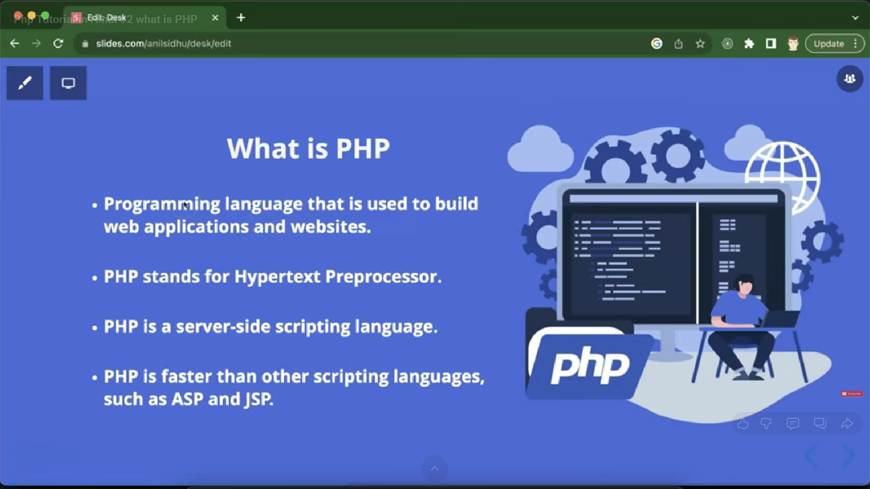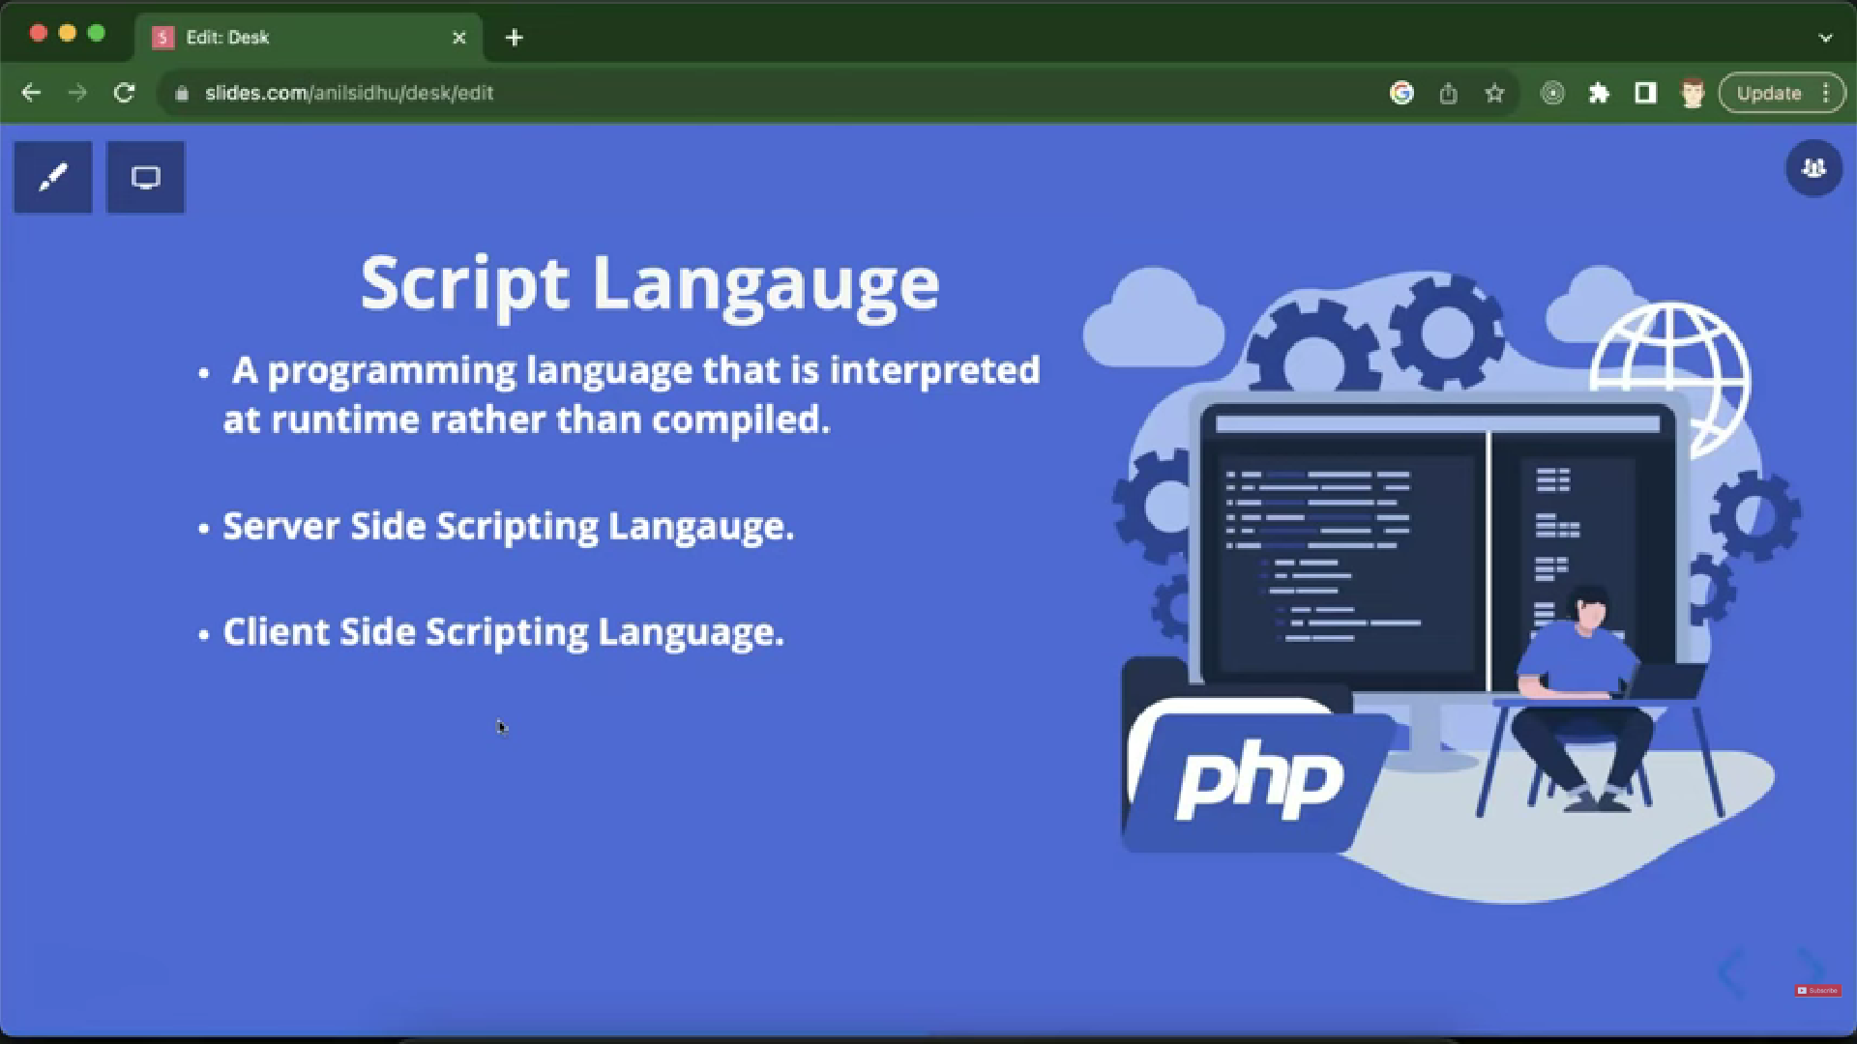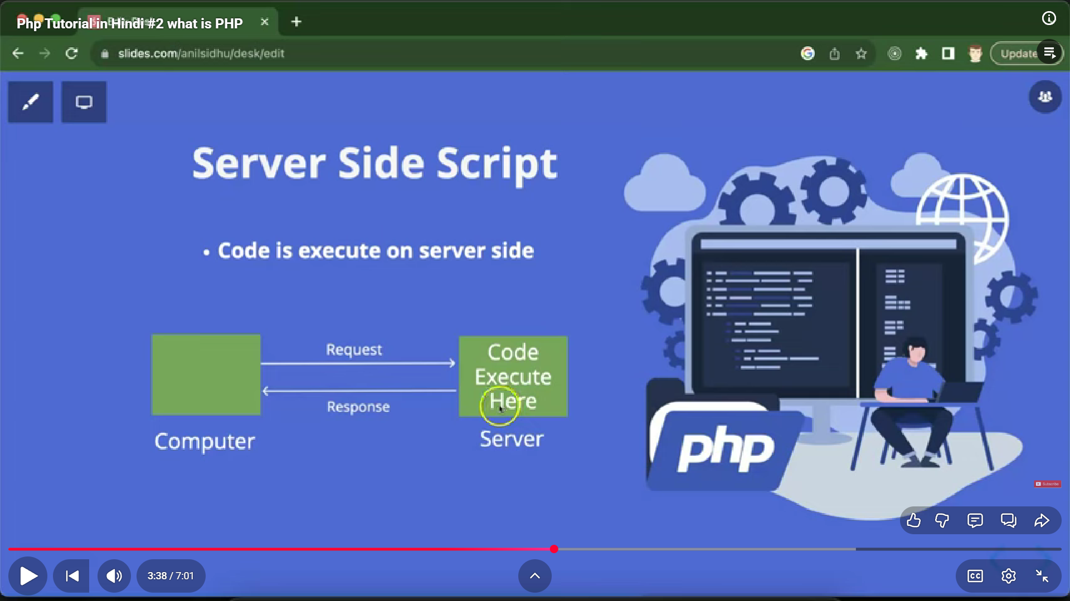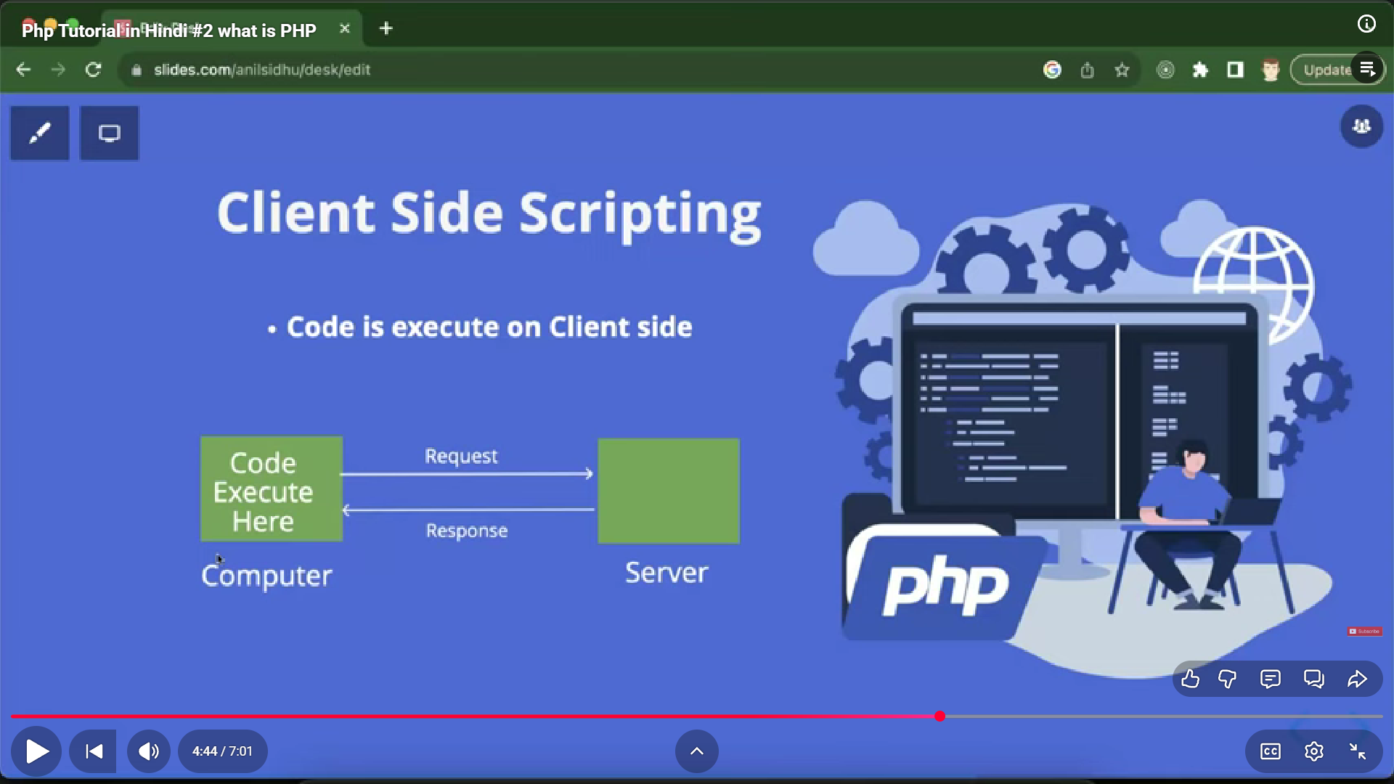

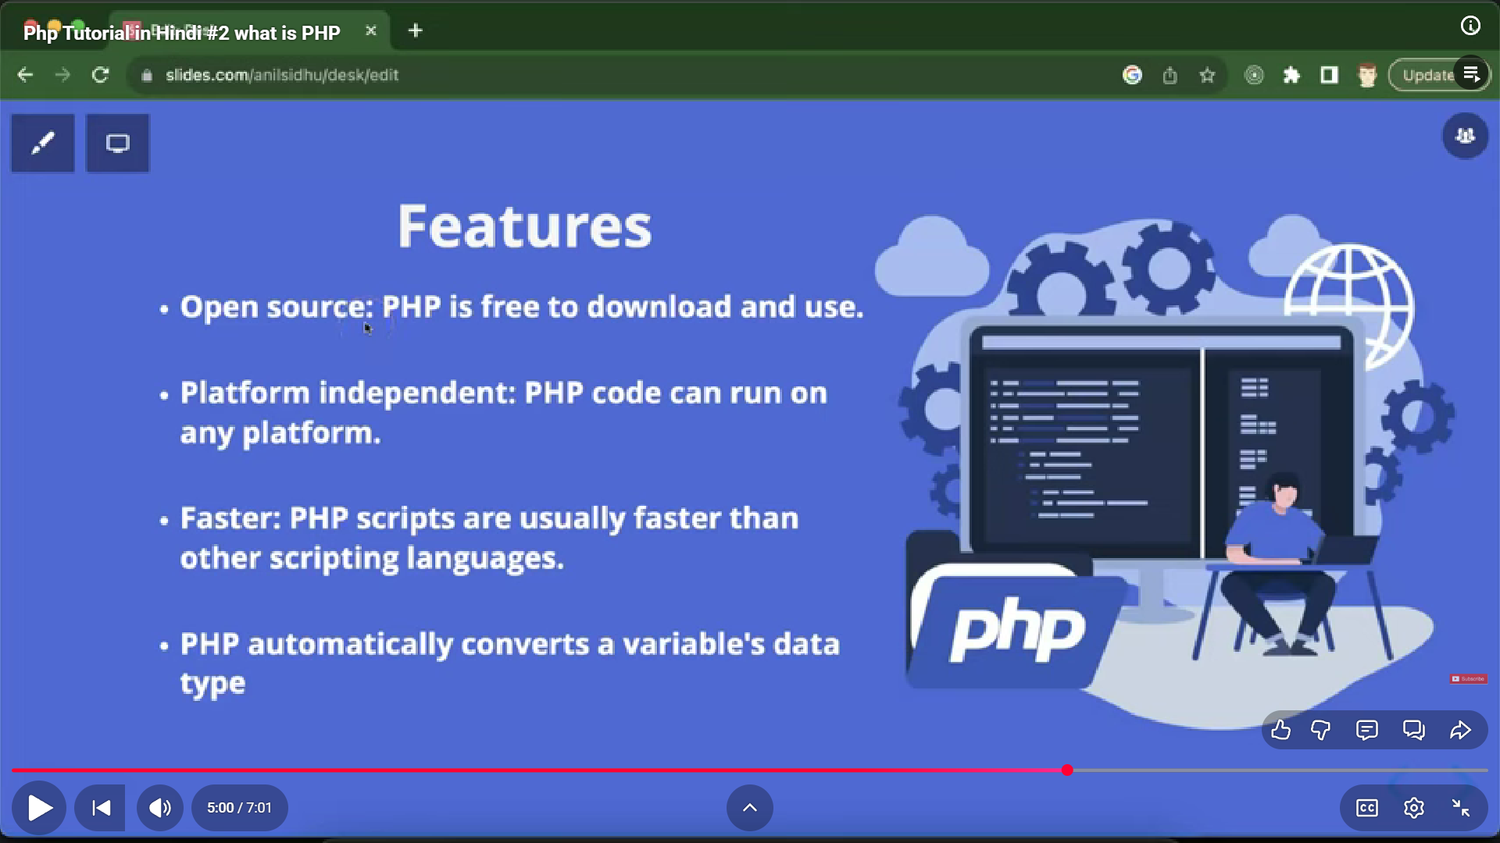

**php** :interpreted server side scrioting language , faster than all other scripting language like asp and jsp . dynamic no dattype declaration,case ensitive but only for variables

* **echo** : language construct, itself doesn't shift to a new line , remains in same line after printing, can be used as a function \[ echo("hi");]
* non case sensitive
* can be used as a function using brackets

<?php

echo "Khushi";

echo "<br/>"; //for line change

?>

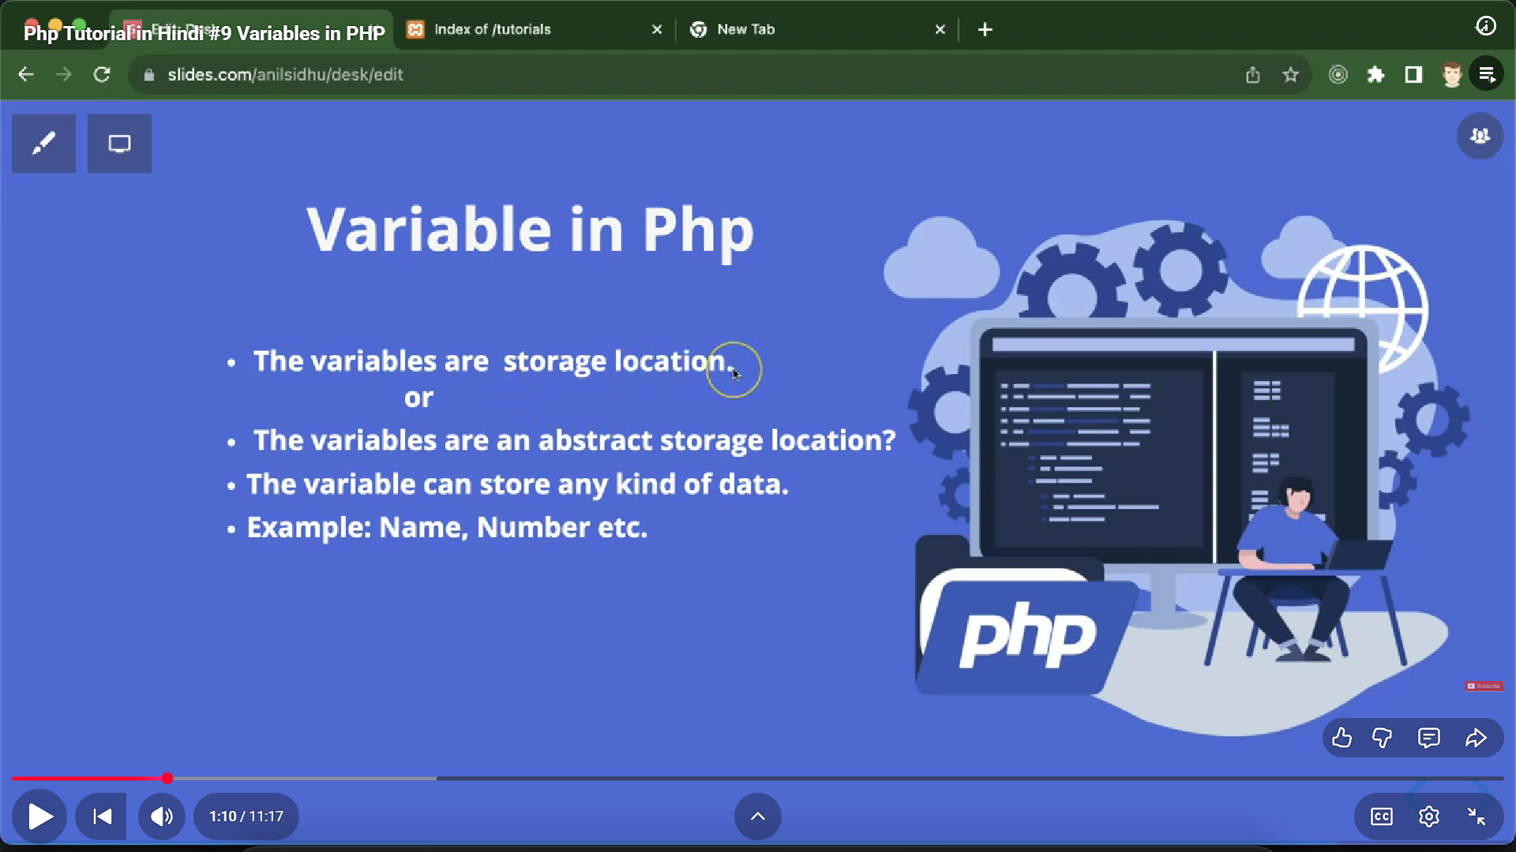

**VariABLES**:

* abstract storage location , stores multiple type of data

$name="Khushi";

* can declare two vars together

$a=$b=10;

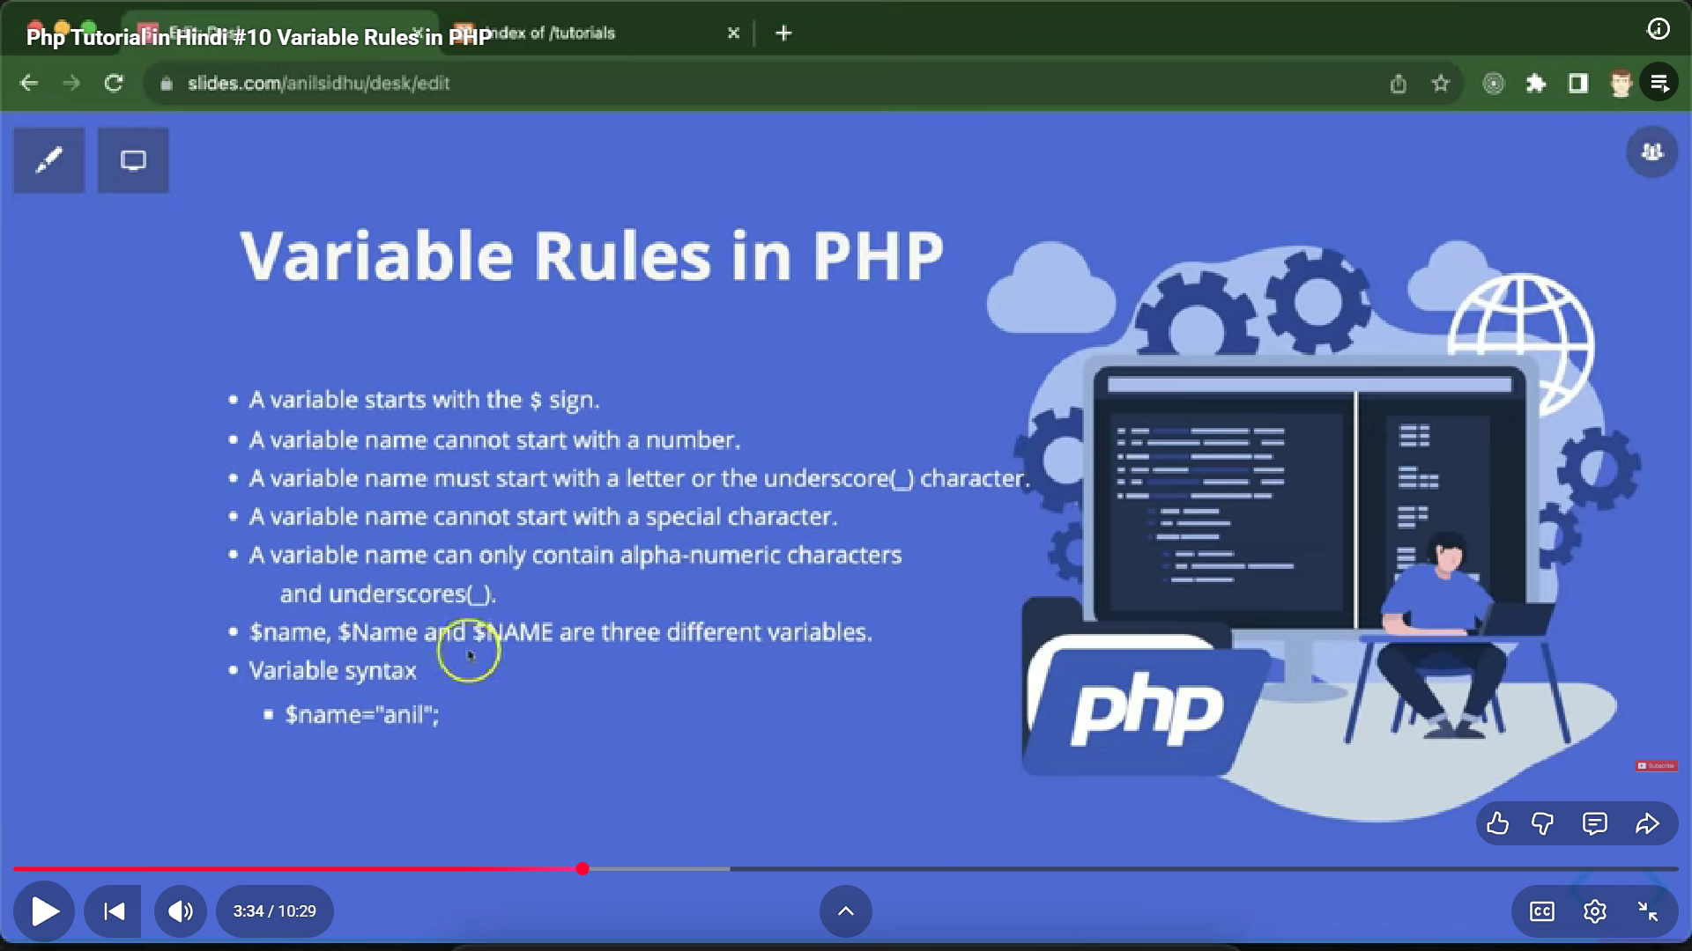

**html inside php:**

echo: echo "<h1> animal </h1>";

**php inside html:**

<h1>

<?php echo $name; ?>

</h1>

**concatenation operator between strings and var name is :**

* echo "hi".$name."bye";
* <?="my"?>//short hand or alternate for echo inside php tag

**To display errors:**

* echo phpinfo();

**phpinfo() is used to display detailed information about your PHP environment — including version, configuration settings, loaded extensions, server information, and more.

* find path to php.ini and open it through terminal
* edit and change display_errors=ON

**constants:**

cant be redeclared or redefined

**a.**const a=5;

//cant be declared inside a function

cant be changed

echo a;

**b.**define("a",5);

//cant be declared inside a class

global scoped but deprecated now

**data types:**

8 total

* string
* int
* float
* null $empty=null;
* Boolean
* array
* object $obj=new Car();
* resource(special datatype to store connections)

**var_dump**:(gives datatype along with value of var)

**print_r():**

**comments:**

1.//single

2./*multiline*/

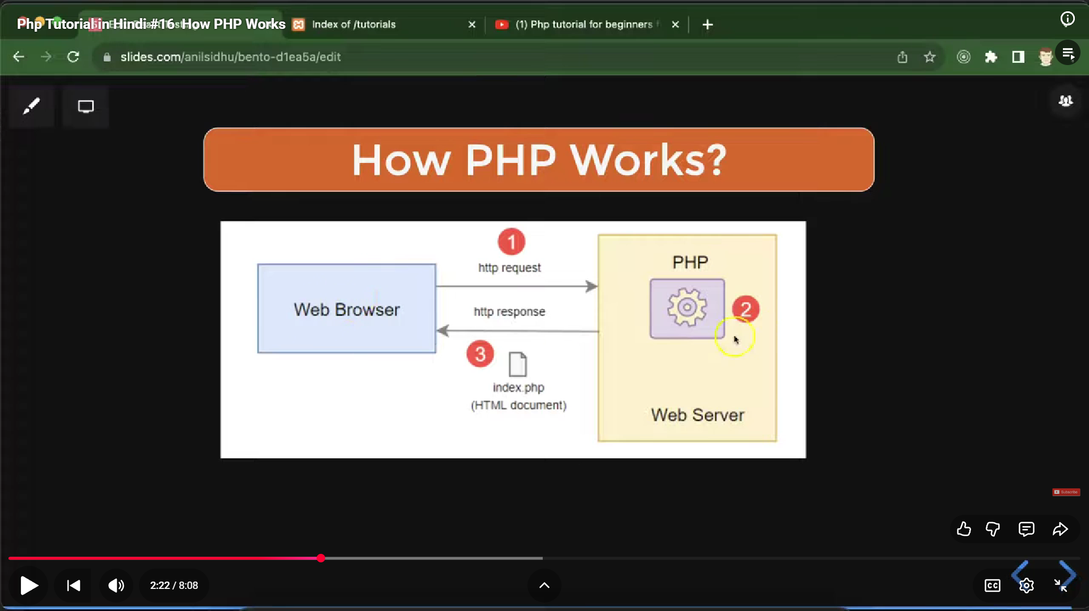

**->**request that we send to server can be seen through network on inspect api calls and their responses too

**->1.**HTML is client-side, so the browser directly displays it and you can see it in Inspect.  
**2.**PHP is server-side, it runs on the server and only sends the output (HTML) to the browser.  
**3.**That’s why the PHP code itself is invisible in the browser or Inspect.

**4.**Browser only processes html,css and js so the interpreter also gives o/p in html

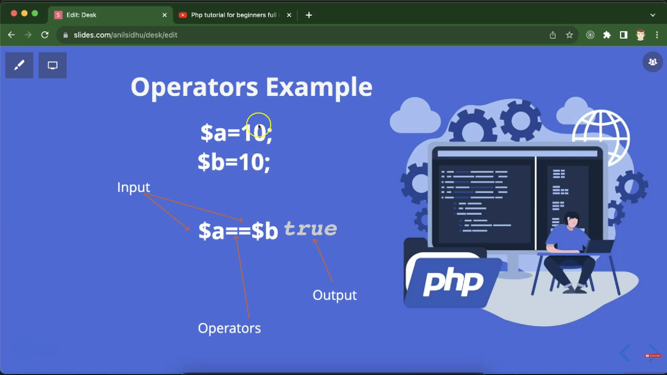

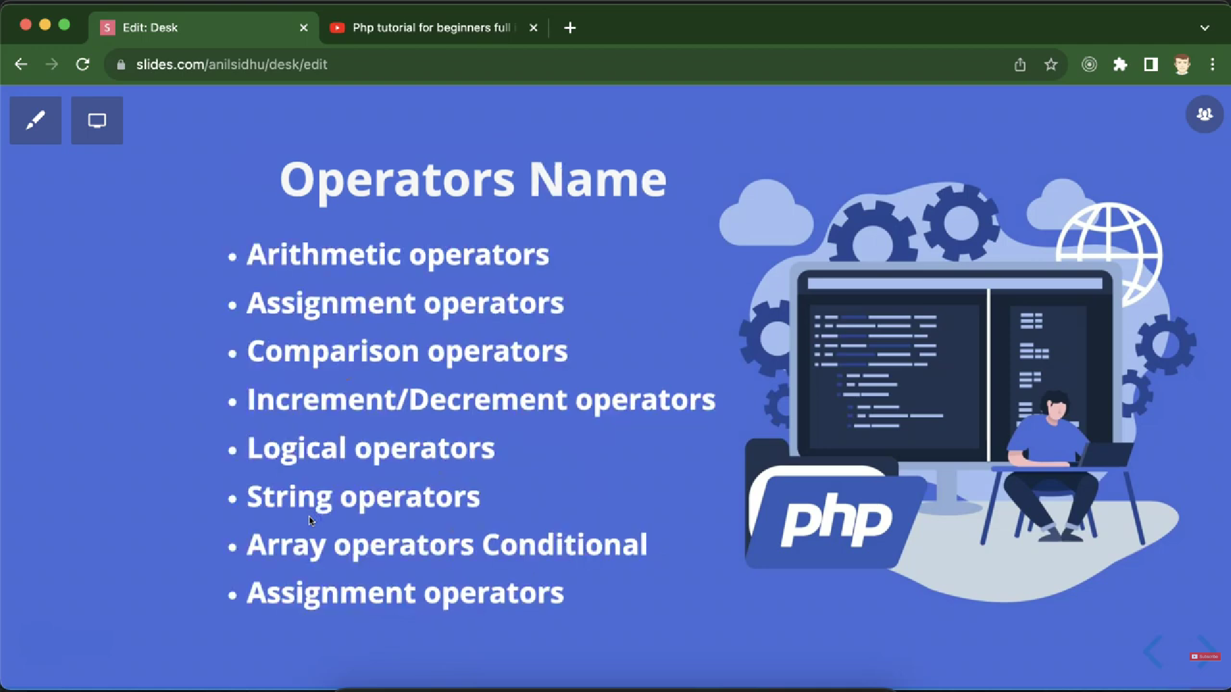

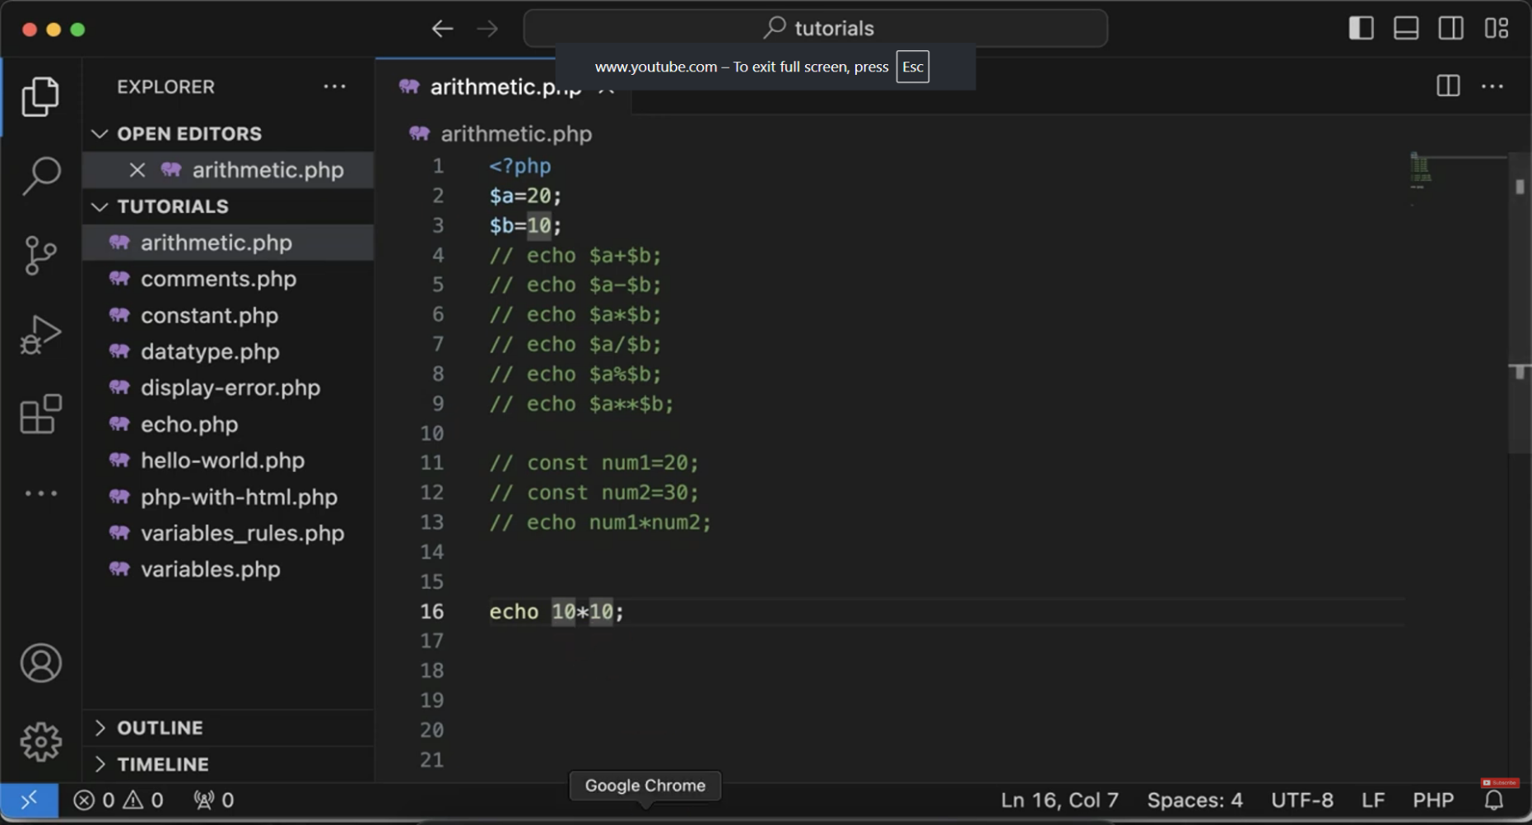

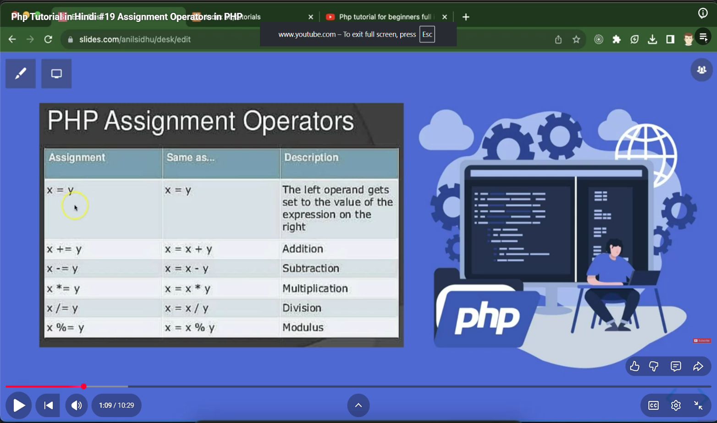

**comparison**:=== for comparing values and their datatype both

* + not equal to
  + !== contrary of ===
  + <=> spaceship operator

The spaceship operator (<=>) in PHP is used for three-way comparison. It returns:

* -1 if the left operand is less than the right operand
* 0 if both operands are equal
* 1 if the left operand is greater than the right operand

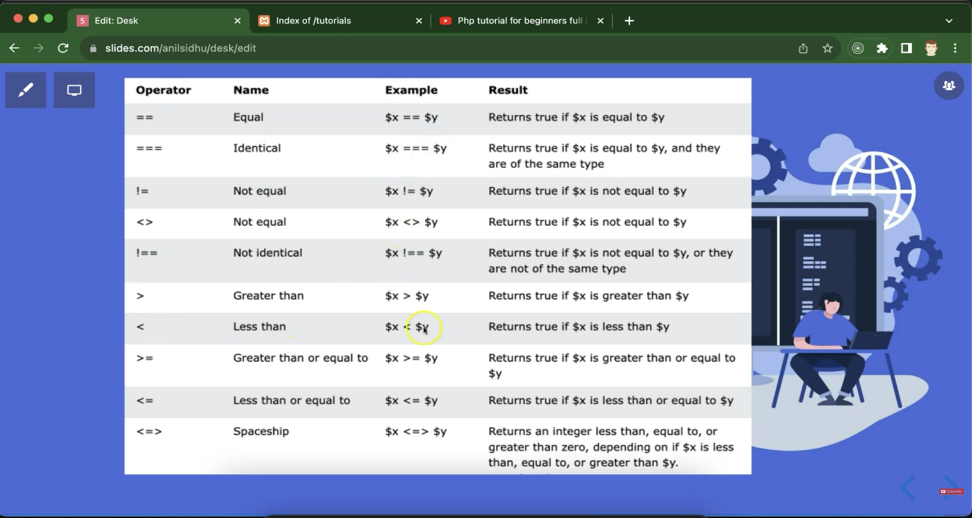

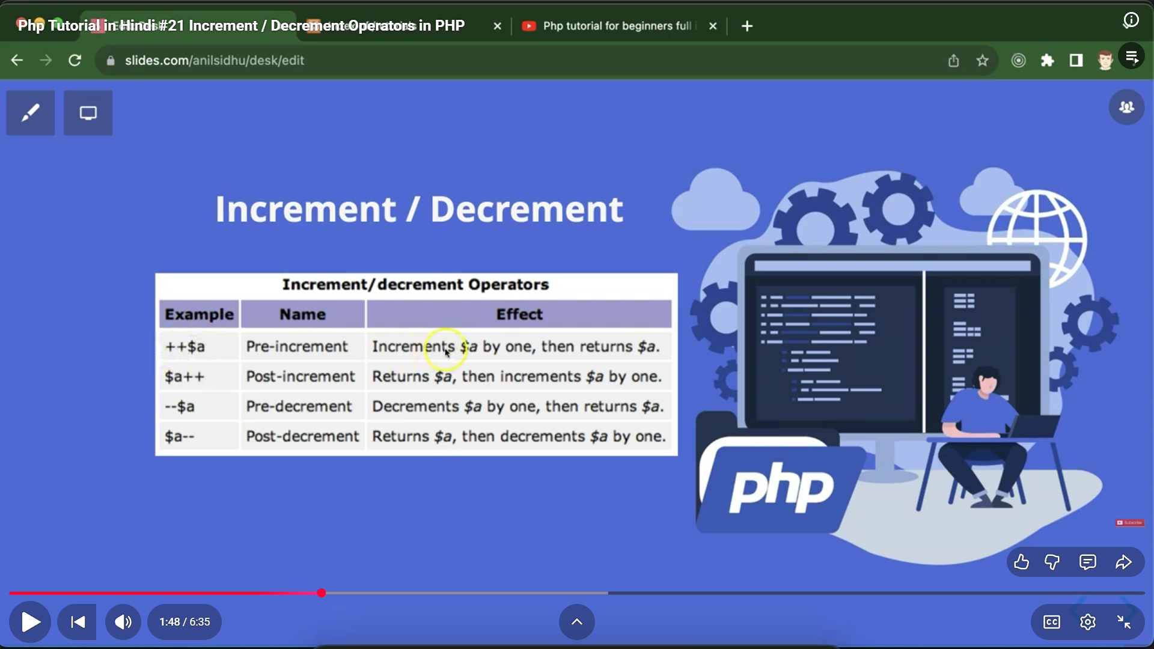

**Strings:**

1. " " ke andr var name as it is daal skte h print ho jaega

2. ' ' ke andr ni hota tou we use . as concatenation operator

3. $str1="hi";(assignment operator)

4. $str2.=$str1(concatenation assignment operator)

**if-else :**

1.normally hi hoga

if(condn){

//condn

}

2. <h1> tag has display:block; bydefault so it changes line automatically while execution

3. if-else

if(condn){

//condn

}else{

//anything

}

4.else if

If(condn){

}elseif(condn){

}else{

}

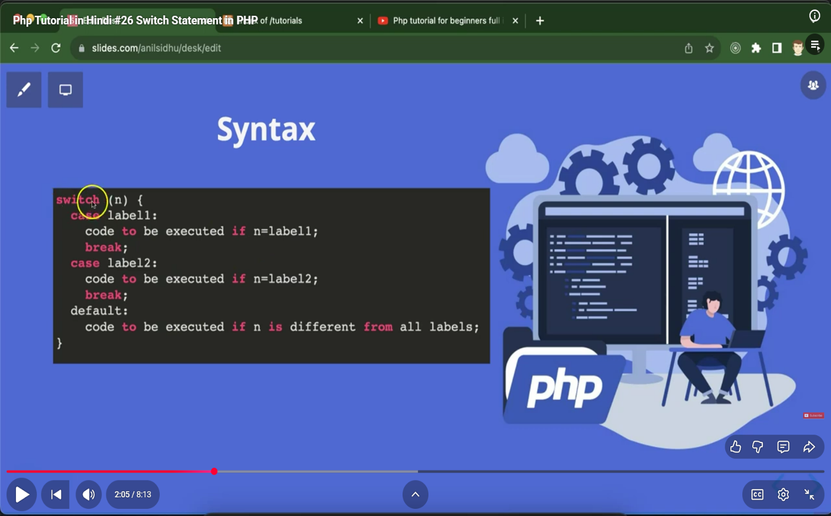

**Use of switch statement:**

The switch statement in PHP is used to compare one value against multiple possible cases — it’s a cleaner alternative to writing many if...else if conditions.

**Logical Operator:**

1.and , &&

2. or , ||

3. !

4. xor: true if any one is true but not both

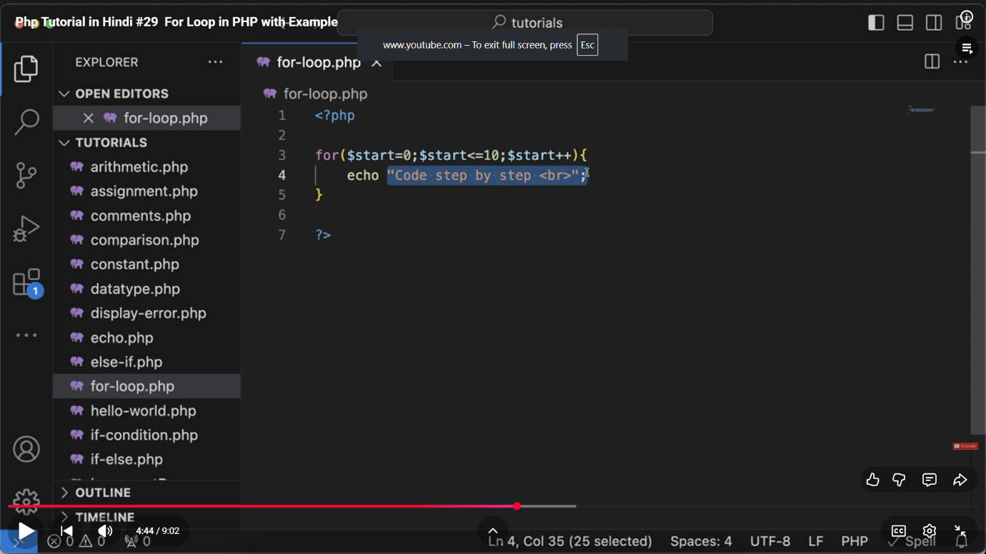

php me break,continue hota hai aur pass nhi hota

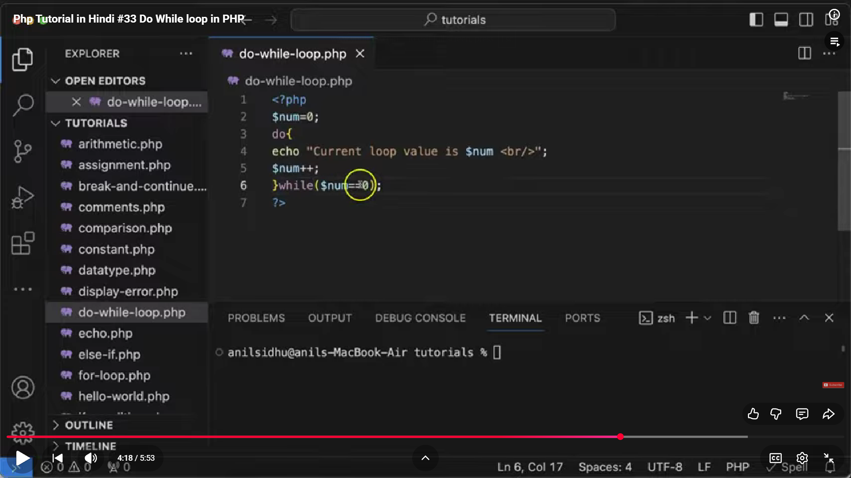

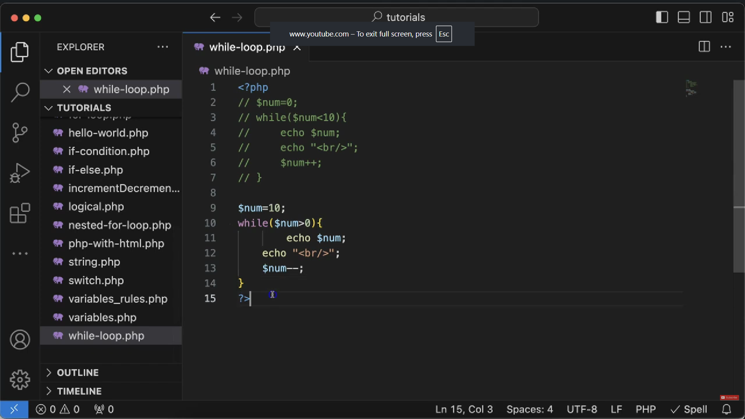

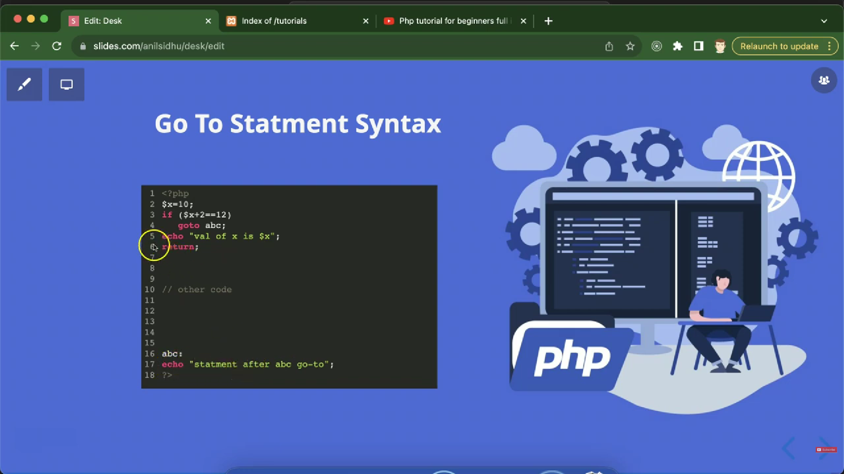

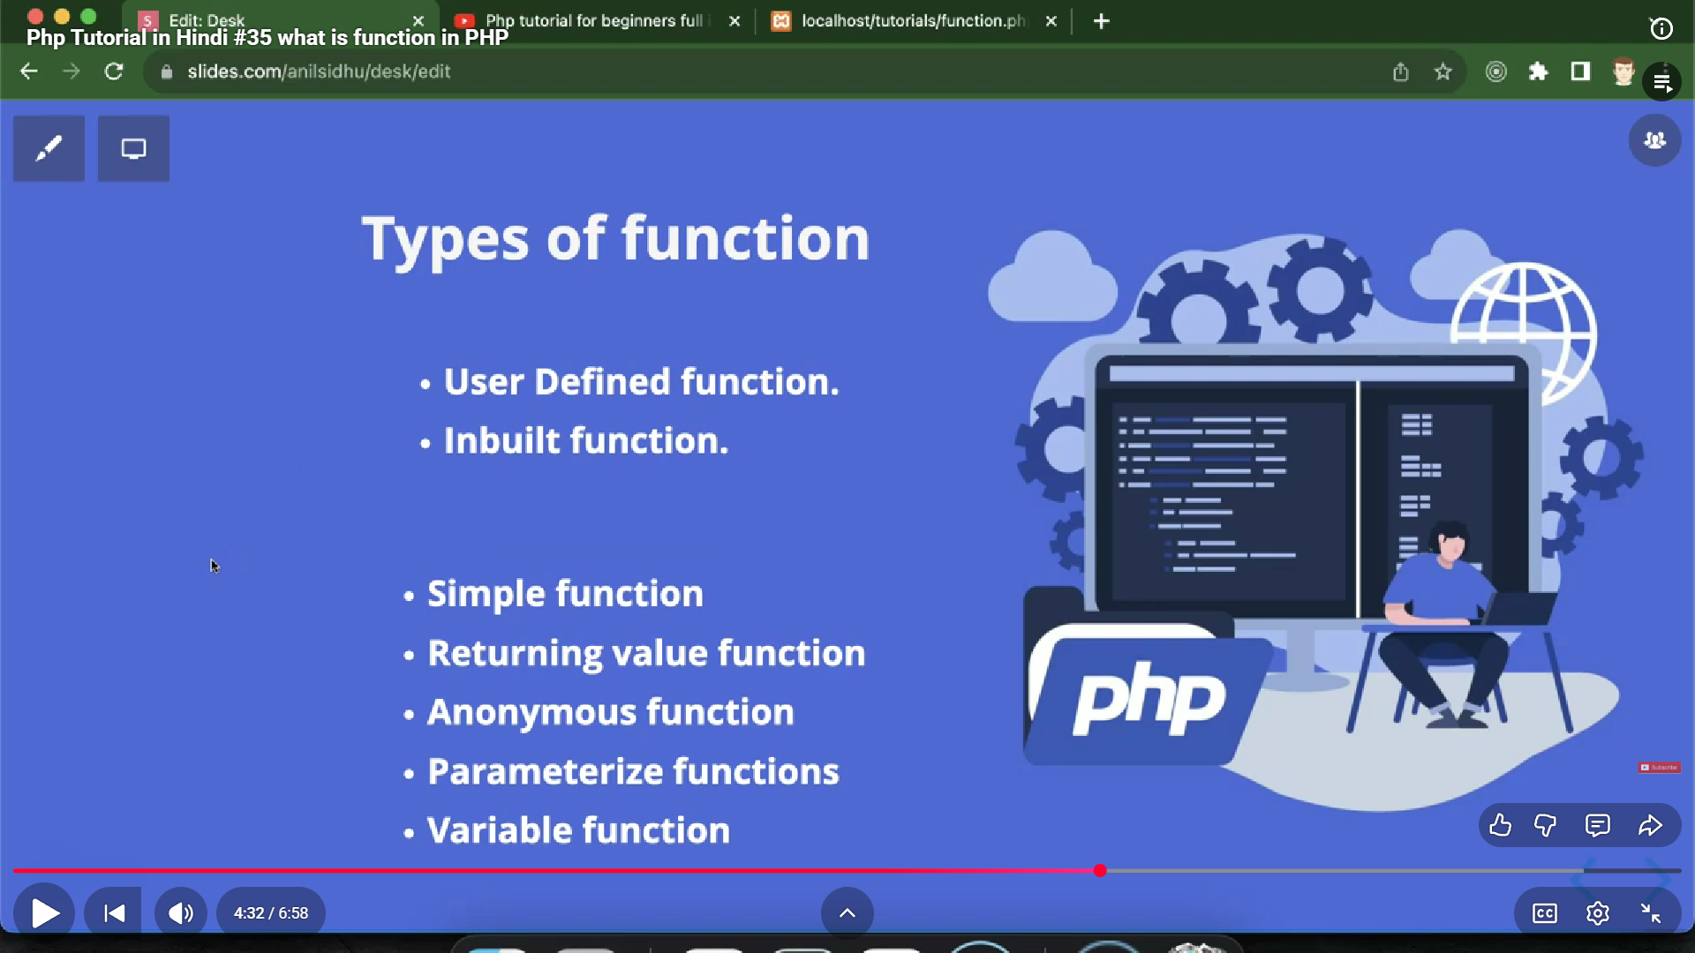

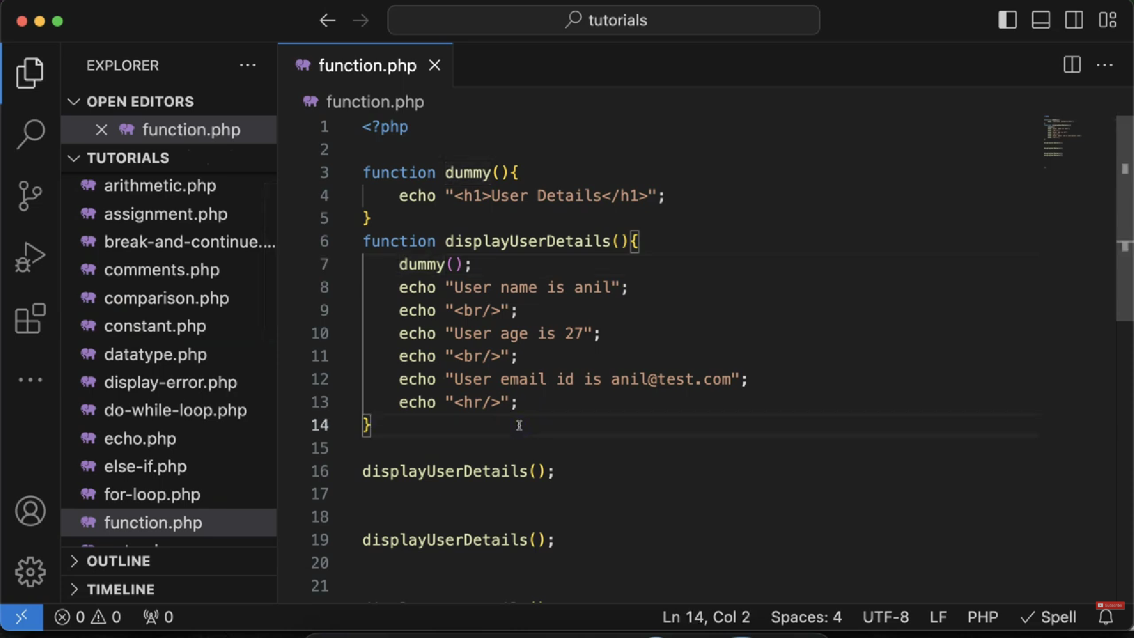

* phle function ko call krke baad me declare kr skte h nd vice versa kyuki functions pure code read ke baad runtime pe call krte h
* Haan, PHP me aap function ko pehle call kar ke baad me declare kar sakte ho, aur vice versa bhi. Reason ye hai ki PHP me functions compile-time me parse ho jate hain, aur runtime pe call possible hota hai. Matlab poora file read ho jata hai aur functions memory me register ho jate hain.

**no error is caused even without php closing tag**

* PHP ka interpreter file ke end tak code read karta hai.
* Agar ?> missing hai, to parser assume kar leta hai ki ye file ka end hai, aur code compile/run ho jata hai.
* Matlab, closing tag optional hai pure PHP files ke liye.

**PHP arguments left to right assign hote hain.**

1. Isliye agar aap first parameter ko default dete ho aur second ko mandatory,
2. to PHP confuse ho jata hai ki "Hello" kis ke liye gaya hai — $name ya $message.
3. PHP me optional (default) parameters hamesha last me hone chahiye.
4. Agar aap first parameter ko default dete ho, aur baad wale ko nahi, to error ya unexpected behavior ho sakta hai.
5. fir dono arg default vala hi lete h value

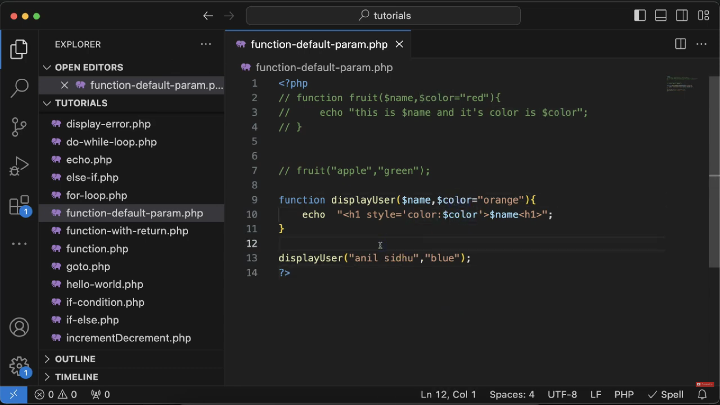

* A closure is a **function inside another function (nested)** that **remembers the outer function’s variables**, even after the outer function has finished executing.

def outer_function(x):

def inner_function(y):

return x + y # inner_function uses x from outer_function

return inner_function # returning the inner function itself

# Create a closure

closure_func = outer_function(10)

print(closure_func(5)) # Output: 15

print(closure_func(20)) # Output: 30

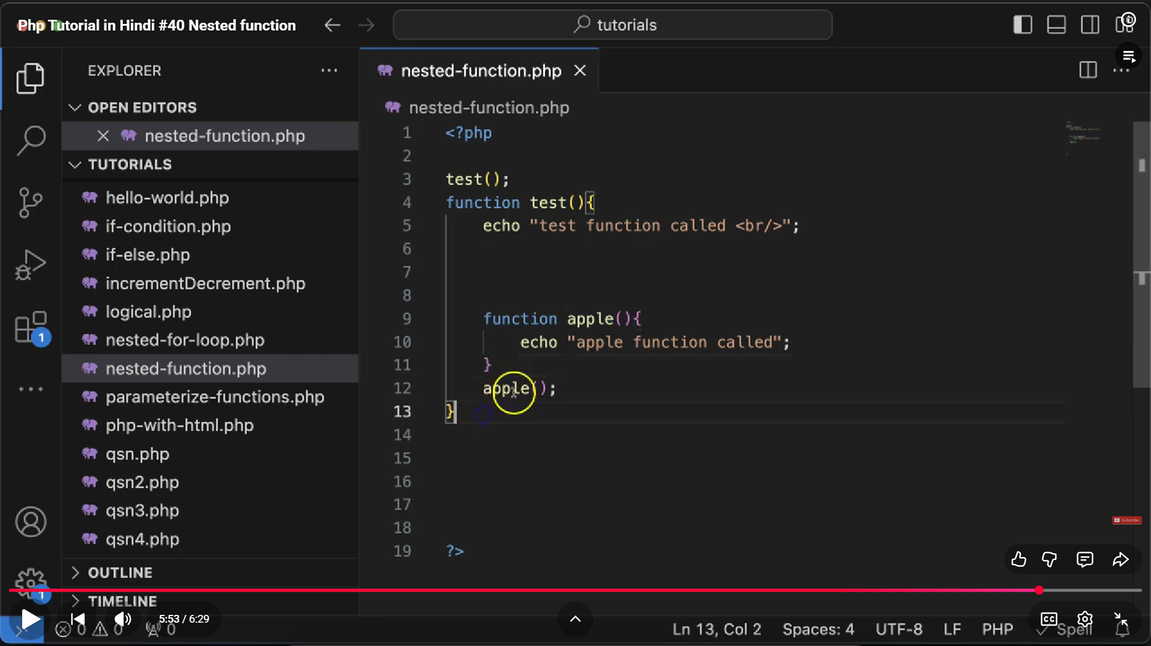

**NESTED FUNCTION**

**nested function tbhi chlega jb uska parent phle call ho chuka hoga**

**3️⃣ Why use nested functions?**

* To encapsulate logic jo sirf ek specific function ke andar kaam kare.
* Memory optimization — inner function tabhi load hoti hai jab outer call hota hai.
* To limit the scope of helper functions.
* Inner function defined only after outer() runs
* It’s not globally available before that
* You can call inner() after outer() Because now PHP knows it Nested functions can’t be called outside if outer not executed Undefined function error
* Useful for restricted or conditional function logic
* Keeps code modular
* You cannot directly call inner() before outer() runs.
* Because PHP me inner() define hi tab hoti hai jab outer() execute hoti hai.

**VARIABLE FUNCTION**

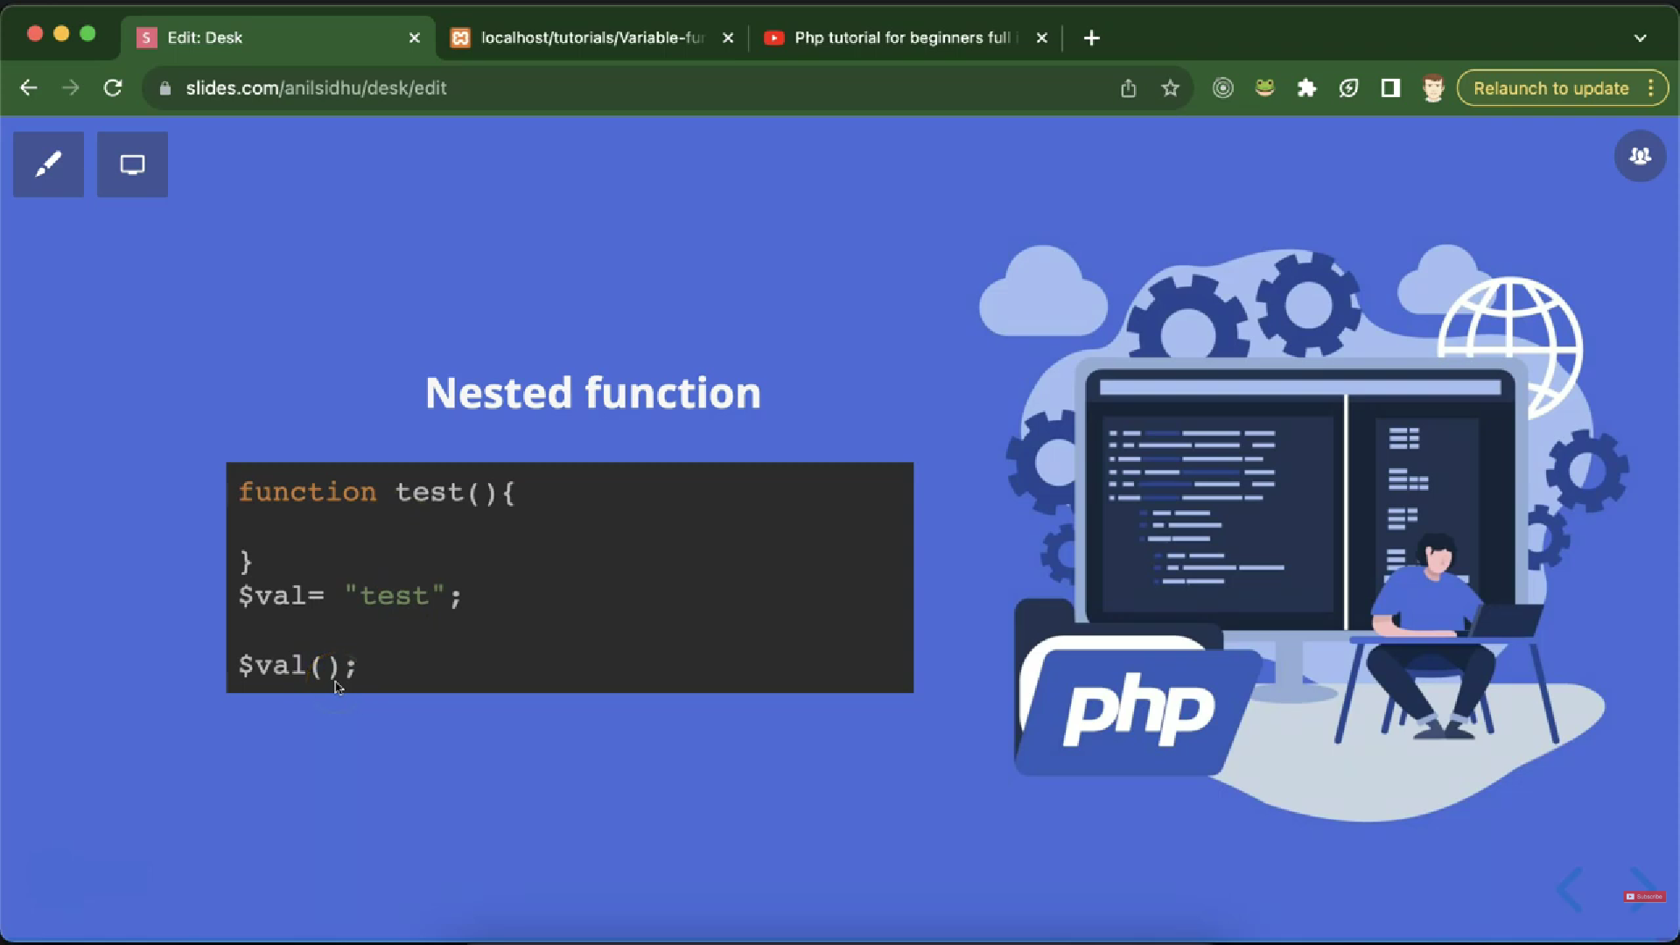

now we have variable functions:

In PHP, variable functions matlab —

aap function ka naam ek variable me store kar sakte ho,

aur us variable se function ko call kar sakte ho.

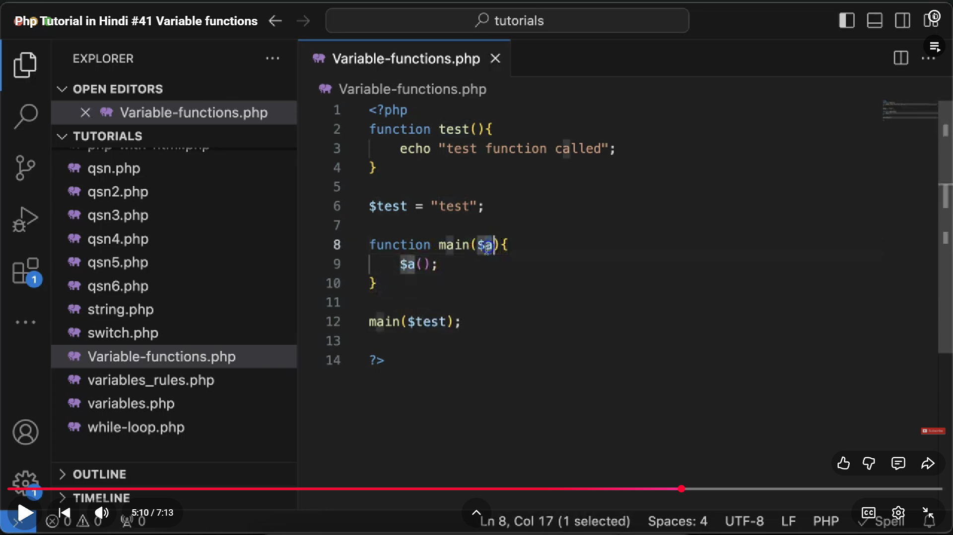

* A **callback function** is a function that is **passed as an argument** to another function and is **called (executed)** inside that function.

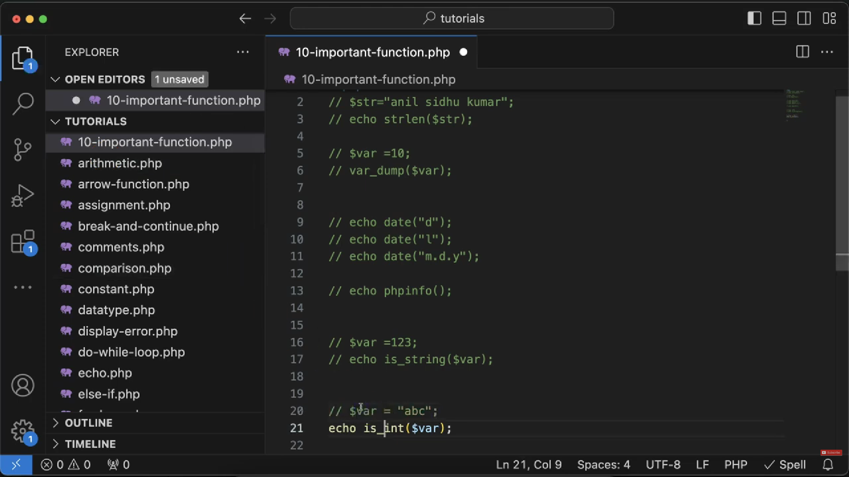

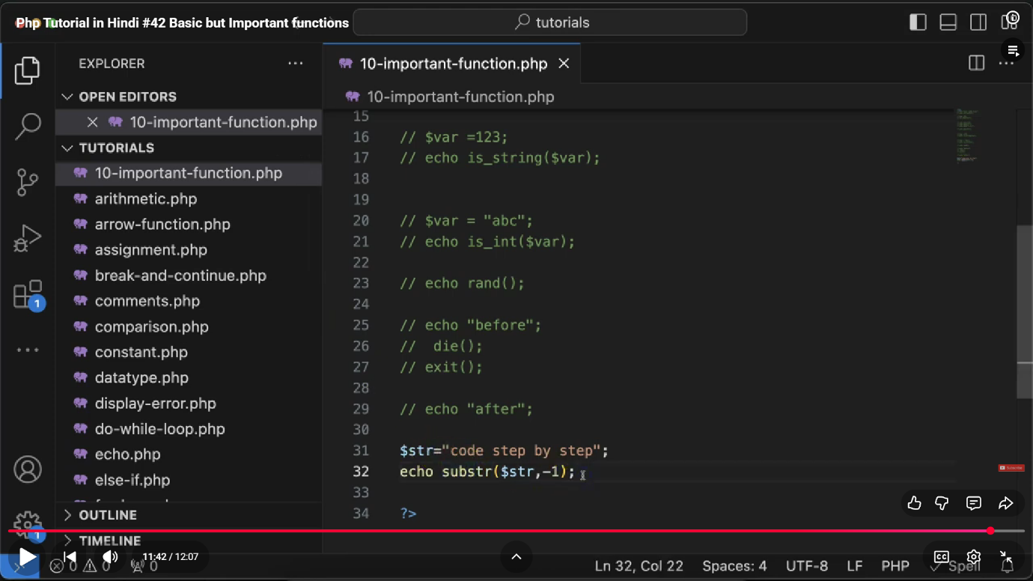

* dd():
* die():
* exit():to stop the execution of whole program
* rand() : function generates a random number

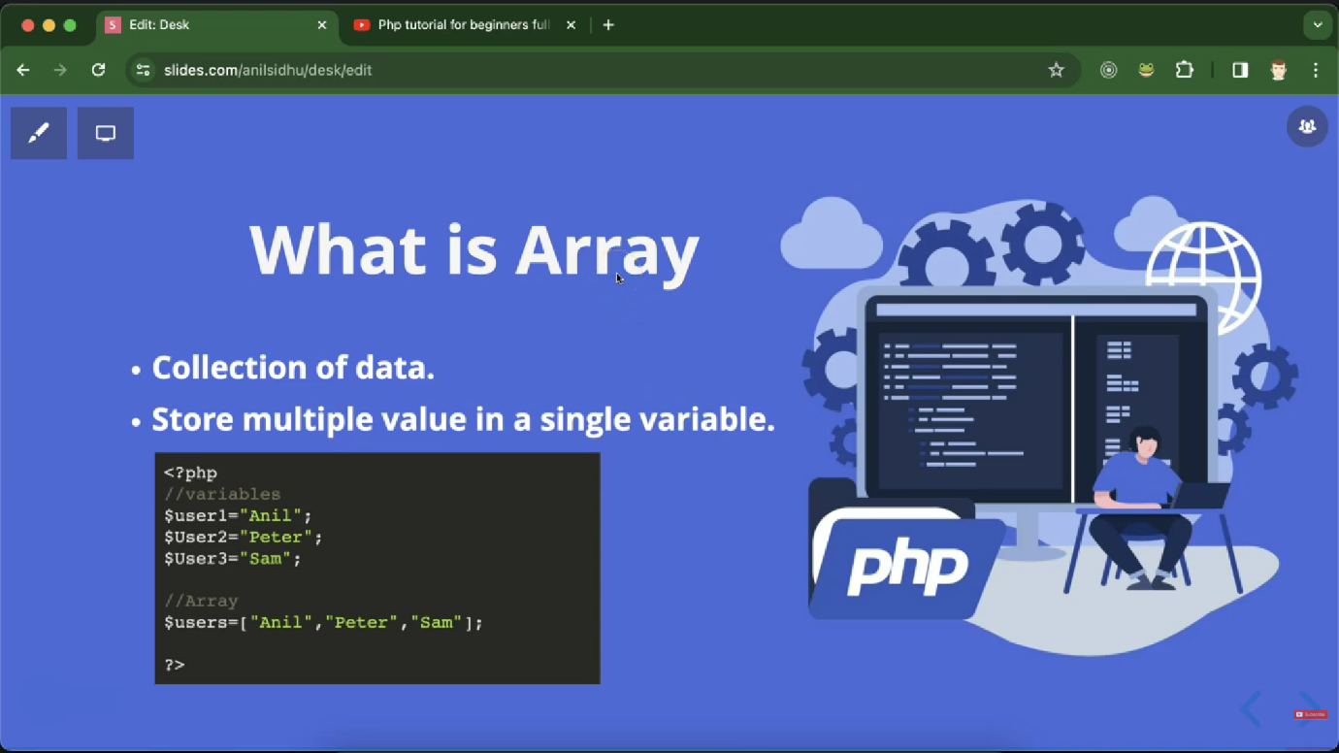

1. array in php can store different datatypes vali values.
2. count($users) gives length of array

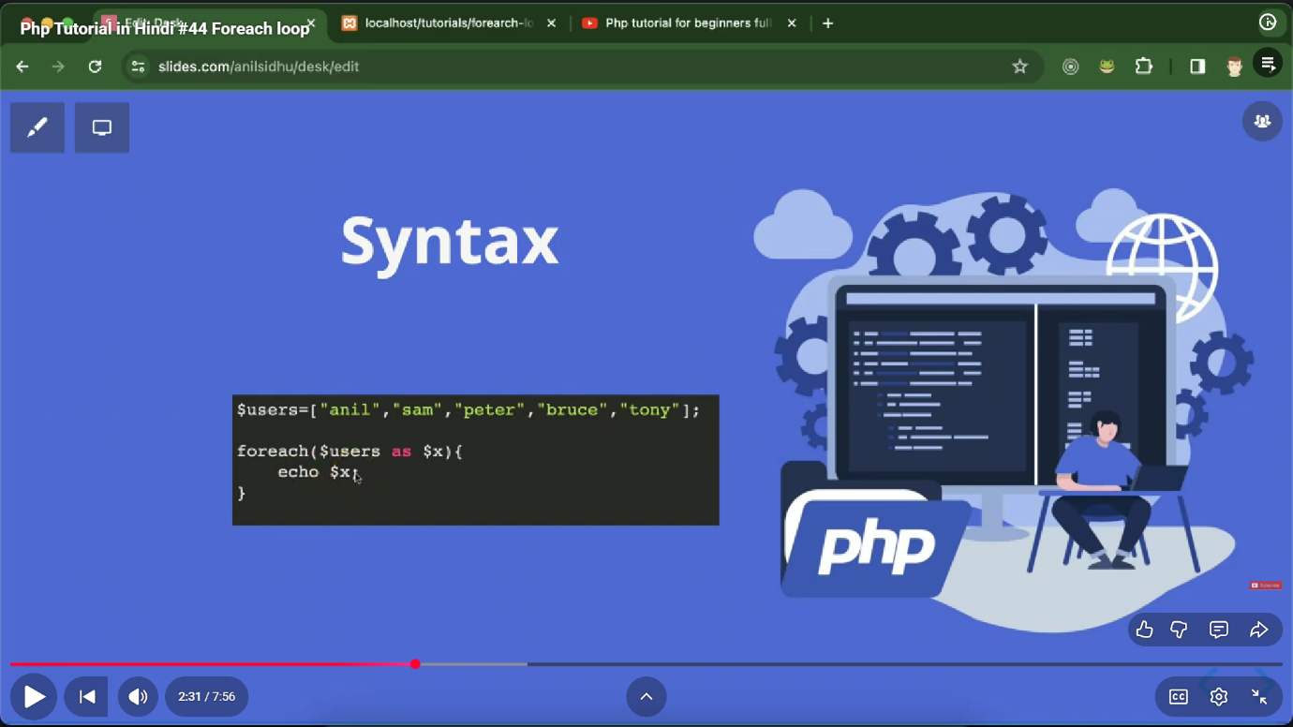

1. for each loop is just like for i in arr in python

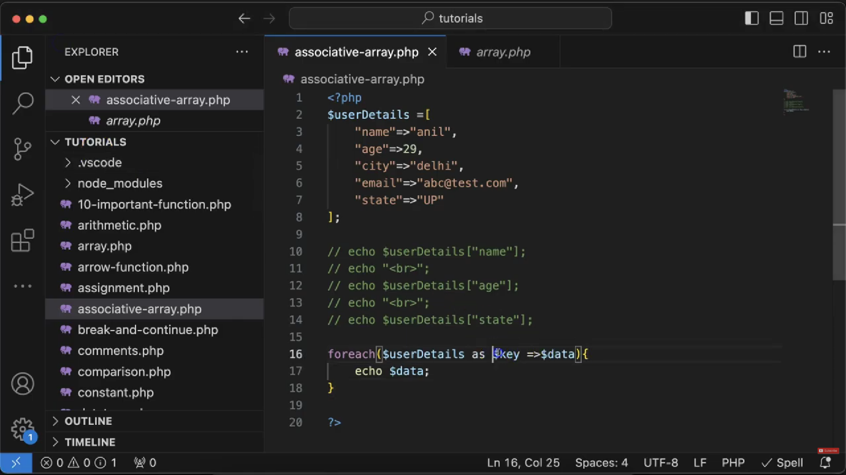

**Associative arrays in PHP**

* used to store and access data using meaningful names (keys) instead of numeric indexes — making your code cleaner, easier to understand, and better suited for real-world structured data.
* $marks = [

"Khushi" => 95,

"Aman" => 89,

"Riya" => 92

];

echo $marks["Khushi"]; // 95

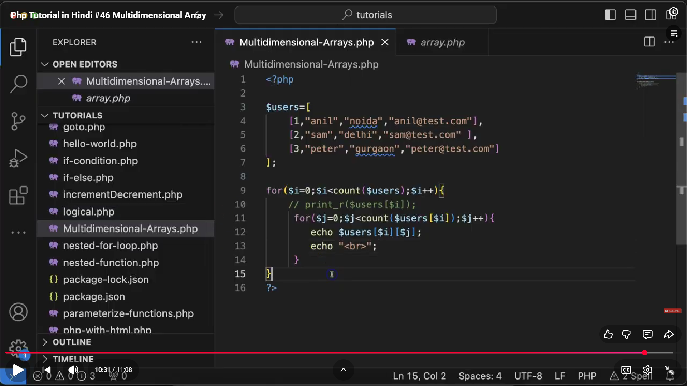

**A multidimensional array means —**

* an array inside another array.
* It stores tabular / hierarchical data (like rows & columns, or nested relationships).
* <?php

$students = [

["name" => "Khushi", "age" => 21, "city" => "Lucknow"],

["name" => "Aman", "age" => 22, "city" => "Delhi"],

["name" => "Riya", "age" => 20, "city" => "Mumbai"]

];

echo $students[0]["name"]; // Output: Khushi

?>

1. Use associative arrays → when you have labeled data.
2. Use multidimensional arrays → when you have data groups or nested sets.

**we cant use echo for arrays , instead use print_r

**Multidimensional Associative Array:**

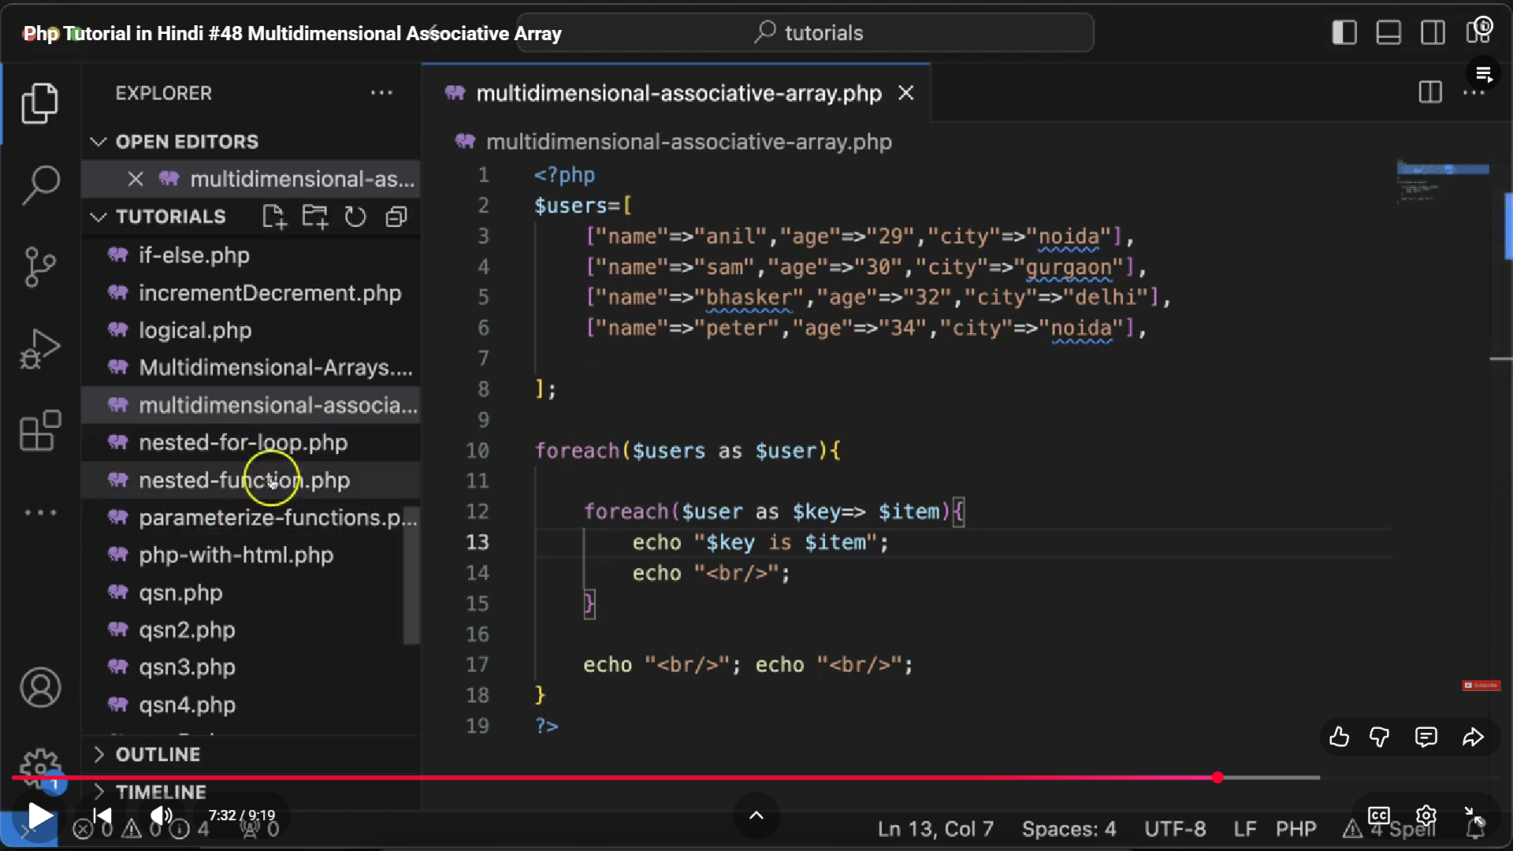

**Array Functions:**

**🔹 1. count()**

Counts the number of elements in an array.

$arr = [1, 2, 3];

echo count($arr); // Output: 3

**🔹 2. array_push()**

Adds one or more elements to the **end** of an array.

$arr = [1, 2];

array_push($arr, 3, 4);

print_r($arr); // [1, 2, 3, 4]

**🔹 3. array_pop()**

Removes and returns the **last** element of an array.

$arr = [1, 2, 3];

echo array_pop($arr); // 3

print_r($arr); // [1, 2]

**🔹 4. array_shift()**

Removes and returns the **first** element.

$arr = ["a", "b", "c"];

echo array_shift($arr); // "a"

print_r($arr); // ["b", "c"]

**🔹 5. array_unshift()**

Adds elements to the **beginning** of an array.

$arr = [2, 3];

array_unshift($arr, 1);

print_r($arr); // [1, 2, 3]

**🔹 6. array_merge()**

Merges two or more arrays into one.

$a = [1, 2];

$b = [3, 4];

print_r(array_merge($a, $b)); // [1, 2, 3, 4]

**🔹 7. array_combine()**

Combines one array as **keys** and another as **values**.

$keys = ["name", "age"];

$values = ["Khushi", 21];

print_r(array_combine($keys, $values));

// ["name" => "Khushi", "age" => 21]

**🔹 8. array_slice()**

Extracts a portion of an array.

$arr = [10, 20, 30, 40, 50];

print_r(array_slice($arr, 1, 3)); // [20, 30, 40]

**🔹 9. array_splice()**

Removes or replaces elements of an array.

$arr = [1, 2, 3, 4];

array_splice($arr, 1, 2, ["a", "b"]);

print_r($arr); // [1, "a", "b", 4]

**🔹 10. array_key_exists()**

Checks if a specific key exists in an array.

$arr = ["name" => "Khushi", "age" => 21];

echo array_key_exists("age", $arr); // true

**🔹 11. in_array()**

Checks if a value exists in an array.

$arr = ["apple", "banana"];

echo in_array("banana", $arr); // true

**🔹 12. array_keys()**

Returns all the keys from an array.

$arr = ["name" => "Khushi", "age" => 21];

print_r(array_keys($arr)); // ["name", "age"]

**🔹 13. array_values()**

Returns all the values from an array.

$arr = ["name" => "Khushi", "age" => 21];

print_r(array_values($arr)); // ["Khushi", 21]

**🔹 14. array_map()**

Applies a function to each element of an array.

$arr = [1, 2, 3];

$squared = array_map(function($n) {

return $n * $n;

}, $arr);

print_r($squared); // [1, 4, 9]

**🔹 15. array_filter()**

Filters elements of an array using a callback.

$arr = [1, 2, 3, 4, 5];

$even = array_filter($arr, fn($n) => $n % 2 == 0);

print_r($even); // [2, 4]

**🔹 16. array_reduce()**

Reduces an array to a single value using a callback.

$arr = [1, 2, 3, 4];

$sum = array_reduce($arr, fn($carry, $n) => $carry + $n, 0);

echo $sum; // 10

**🔹 17. array_unique()**

Removes duplicate values.

$arr = [1, 2, 2, 3, 3, 4];

print_r(array_unique($arr)); // [1, 2, 3, 4]

**🔹 18. sort() and rsort()**

Sort arrays in ascending or descending order.

$arr = [5, 2, 8, 1];

sort($arr); // Ascending

print_r($arr);

rsort($arr); // Descending

print_r($arr);

**🔹 19. array_reverse()**

Returns an array with elements in reverse order.

$arr = [1, 2, 3];

print_r(array_reverse($arr)); // [3, 2, 1]

**🔹 20. array_diff()**

Finds the difference between arrays (values not present in another).

$a = [1, 2, 3, 4];

$b = [3, 4, 5];

print_r(array_diff($a, $b)); // [1, 2]

**🧠 Pro Tip (Interview Shortcut):**

Group them logically:

* **Adding/Removing:** array_push, array_pop, array_shift, array_unshift, array_splice
* **Combining/Splitting:** array_merge, array_combine, array_slice
* **Checking:** in_array, array_key_exists
* **Mapping/Filtering:** array_map, array_filter, array_reduce
* **Sorting:** sort, rsort, array_reverse
* **Unique/Diff:** array_unique, array_diff

| **Feature** | | | **Type Casting 🧭** | | | **Type Conversion ⚙️** | |
| --- | --- | --- | --- | --- | --- | --- | --- |
| **Definition** | | | Manually converting the data type of a variable to another type. | | | Automatically converting the data type by PHP itself. | |
| **Who does it?** | | | Done **explicitly by the programmer**. | | | Done **implicitly by the PHP interpreter**. | |
| **Syntax** | | | (int)$var, (float)$var, (string)$var, (bool)$var, etc. | | | Happens automatically — no special syntax. | |
| **Example** | | | $x = "10";  $y = (int)$x;  // Type Casting | | | $x = "10" + 5;  // Type Conversion → PHP converts "10" to int automatically | |
| **Keyword** | **Description** | | **Behavior if File Missing** | **Reinclusion** | | **Use Case Example** | |
| **include** | Includes and evaluates a file. | | ⚠️ **Warning** (script continues) | Can be included **multiple times**. | | Optional files, like headers or footers. | |
| **require** | Includes and evaluates a file. | | ❌ **Fatal error** (script stops) | Can be included **multiple times**. | | Essential files (e.g., database config, core logic). | |
| **include_once** | Includes file **only once**, even if called again. | | ⚠️ **Warning** (script continues) | Prevents duplicate inclusion. | | Use when same file might be included multiple times accidentally. | |
| **require_once** | Requires file **only once**, even if called again. | | ❌ **Fatal error** (script stops) | Prevents duplicate inclusion. | | Use for critical files that must be loaded once (e.g., connection.php). | |

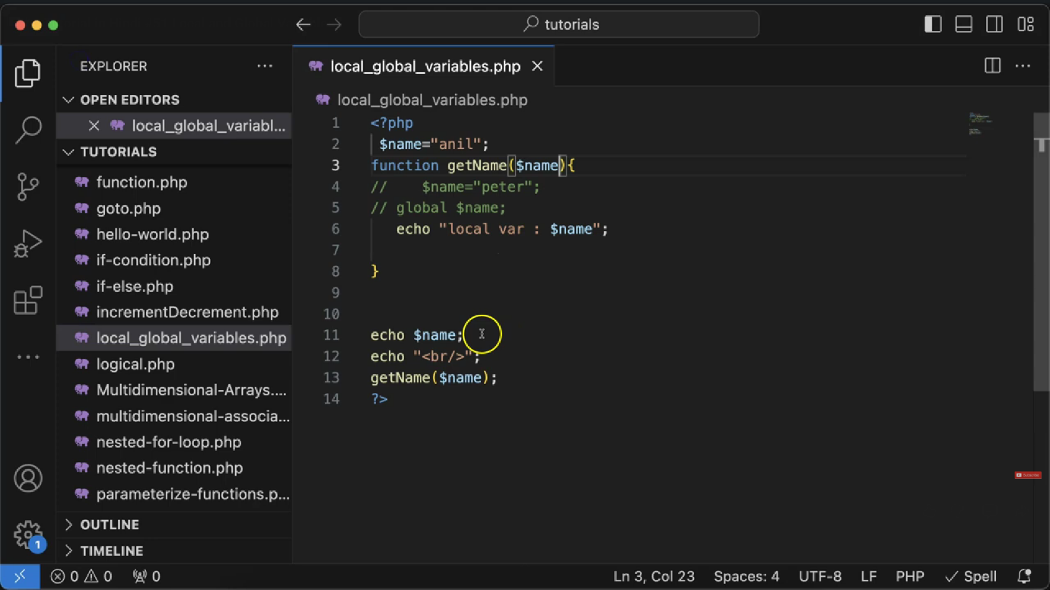

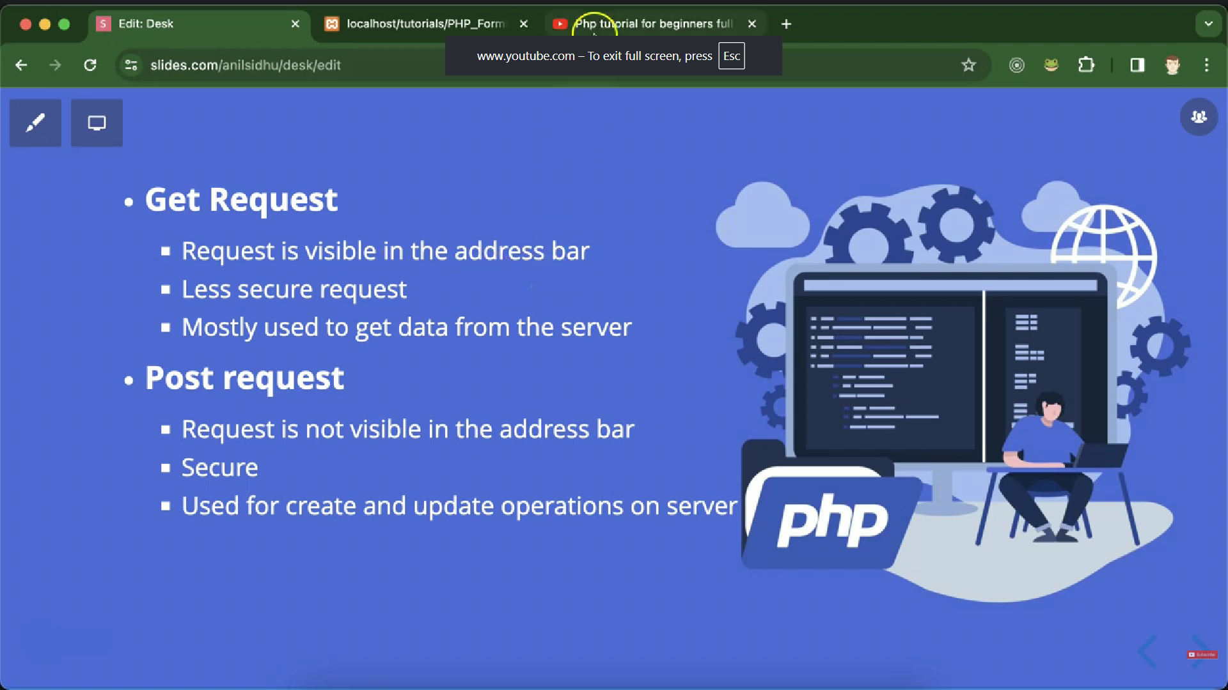

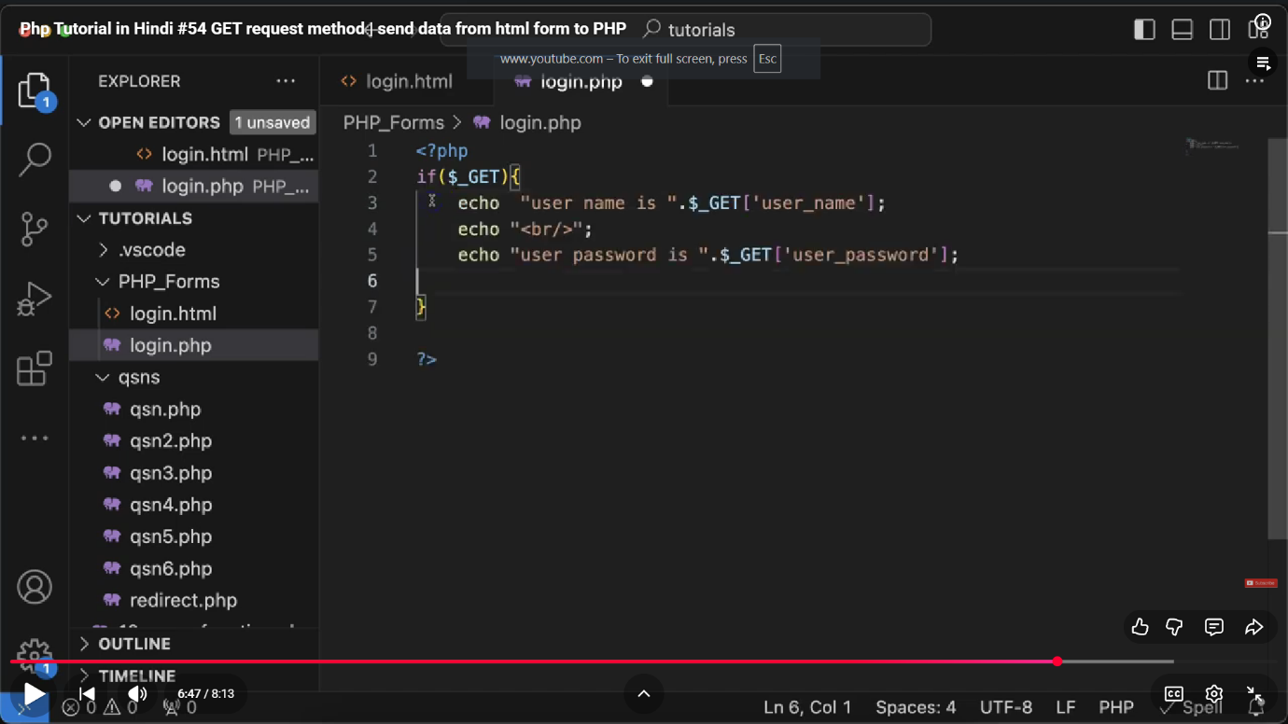

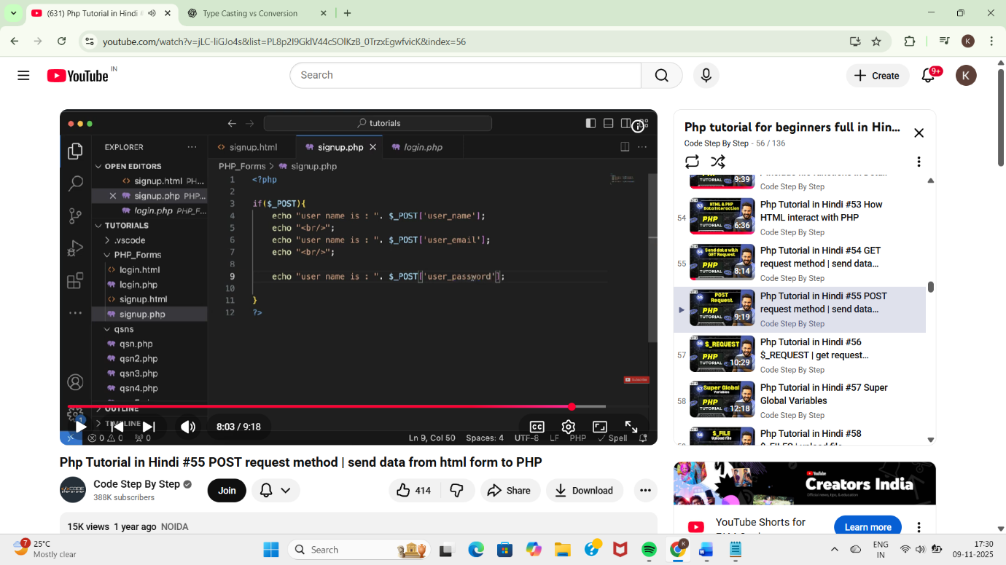

**🔹 $_GET**

* Used to collect data sent through the **URL**.
* Data is **visible** in the address bar.
* Used for **non-sensitive** or short data (like search queries).
* Syntax: $_GET['key'].

**🔹 $_POST**

* Used to collect data sent through an **HTML form** using POST method.
* Data is **not visible** in the URL.
* Used for **sensitive or large** data (like passwords, forms).
* Syntax: $_POST['key'].

**🔹 $_REQUEST**

* Can collect data from **GET, POST, and COOKIE**.
* Handy when the request method is **unknown**.
* ⚠️ Less secure — avoid for sensitive data.
* Syntax: $_REQUEST['key'].
* $_REQUEST: super-global variable // get or post request dono ka data show krta hai
* echo $_REQUEST["name"];
* $REQUEST["age"]=56;

🔹 **implode() Function**

Purpose:** Converts an **array → string**.

Syntax:** `implode(separator, array)`

Example:

$arr = ["Apple", "Banana", "Cherry"];

echo implode(", ", $arr);

// Output: Apple, Banana, Cherry

🔹 **explode() Function**

Purpose:** Converts a **string → array** (opposite of implode).

Syntax:** `explode(separator, string)`

Example:

$str = "Apple, Banana, Cherry";

$arr = explode(", ", $str);

print_r($arr);

// Output: Array ( [0] => Apple [1] => Banana [2] => Cherry )

```

✅ **Quick Tip:**

`implode()` = join array → string

`explode()` = split string → array

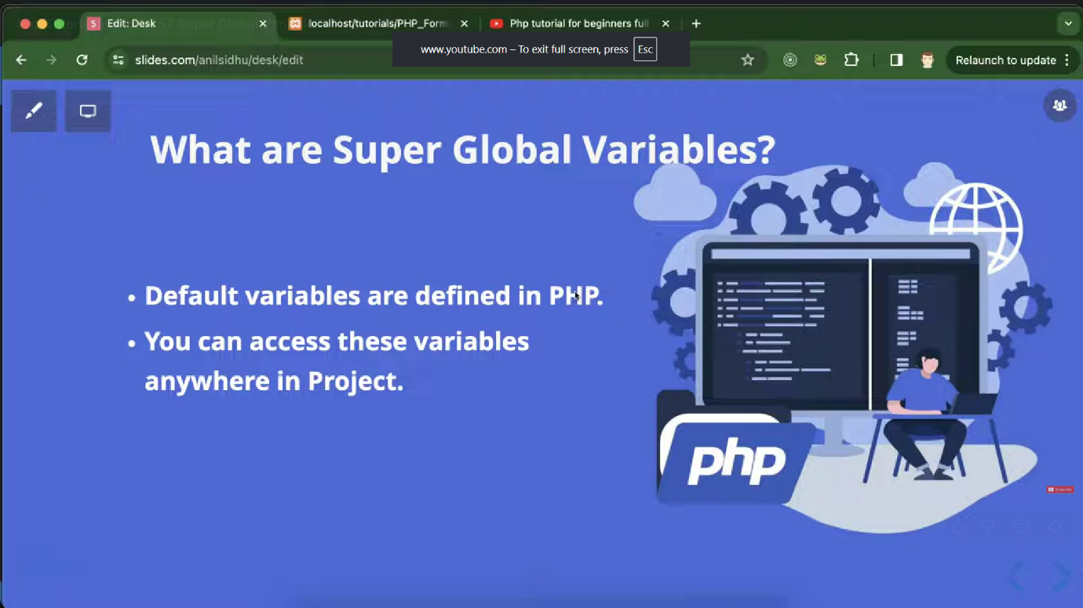

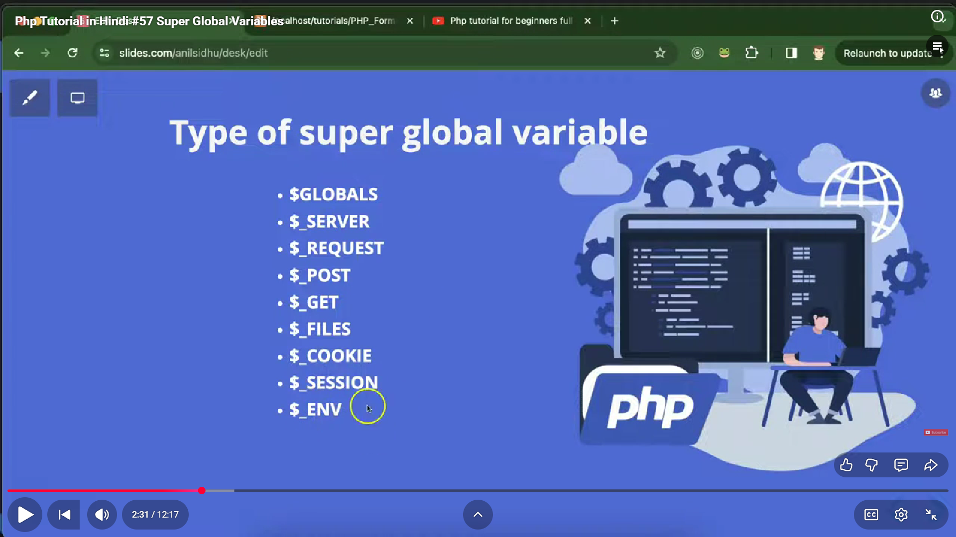

**🔹 $GLOBALS in PHP**

* It is a **superglobal array** that stores **all global variables** in PHP.
* Accessible **from anywhere** — inside or outside functions.
* Each global variable is stored as an element of $GLOBALS with its **variable name as the key**.
* Syntax: $GLOBALS['variable_name'].
* Useful when you need to **access or modify global variables inside a function**.
* Even all request.get,post all sort of variables

**🔹 $_SERVER in PHP**

* A **superglobal array** that contains **information about the server and the current request**.
* Data includes headers, paths, script locations, request methods, etc.
* Automatically populated by PHP (no need to declare).
* Syntax: $_SERVER['key'].

| **Key** | **Description** |
| --- | --- |
| $_SERVER['PHP_SELF'] | The filename of the current script. |
| $_SERVER['SERVER_NAME'] | The name of the host server (e.g., localhost). |
| $_SERVER['HTTP_HOST'] | The current domain name. |
| $_SERVER['REQUEST_METHOD'] | The request method used (GET, POST, etc.). |
| $_SERVER['SCRIPT_NAME'] | The path of the current script. |
| $_SERVER['REMOTE_ADDR'] | The IP address of the client. |
| $_SERVER['HTTP_USER_AGENT'] | Information about the user’s browser and OS. |

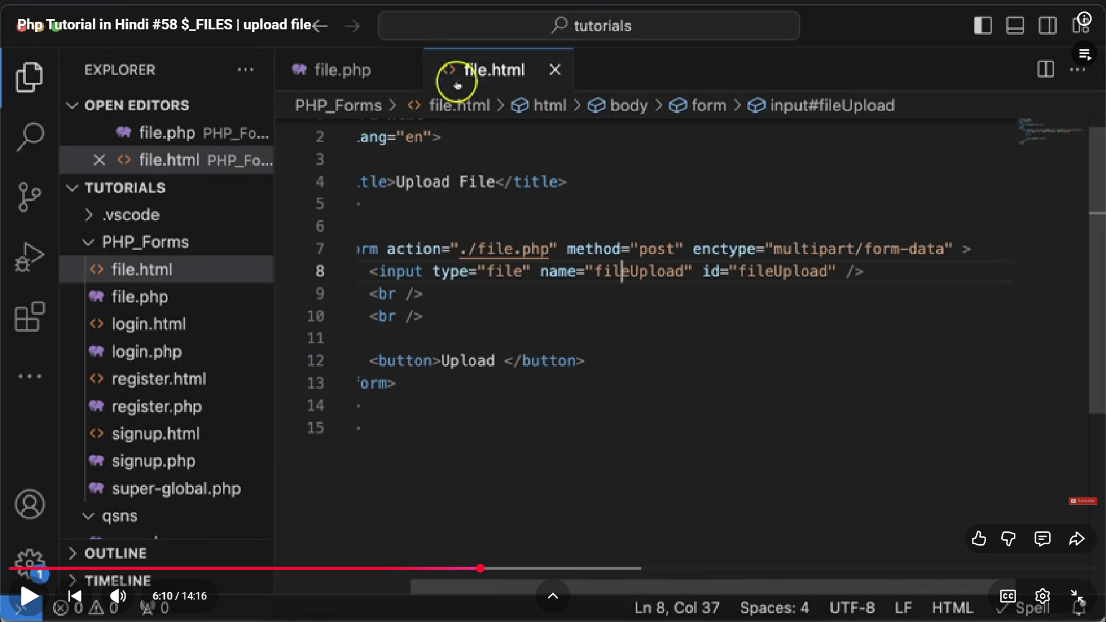

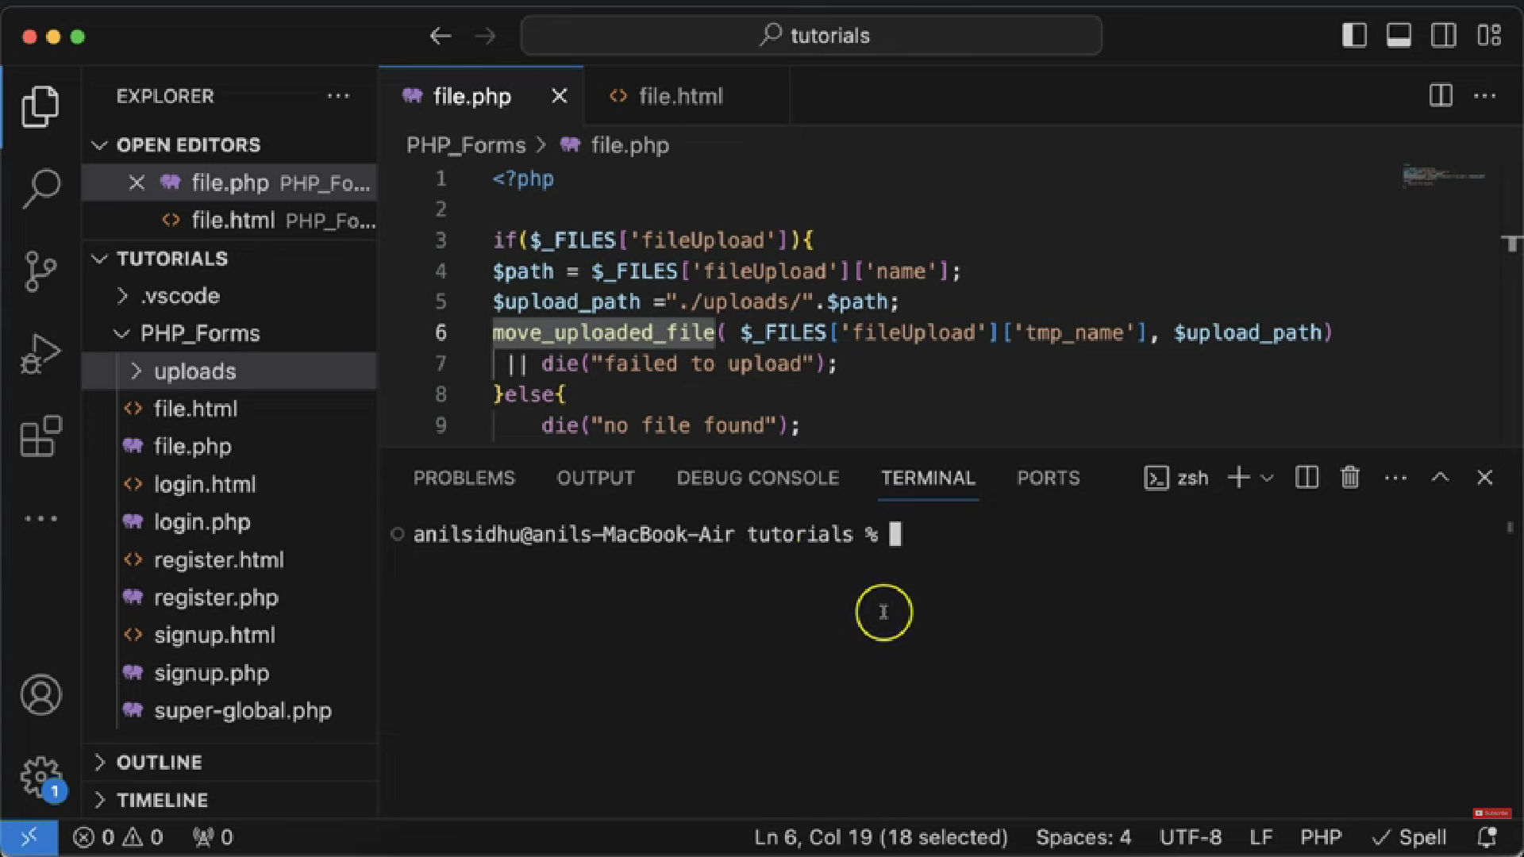

* $_FILES is a **superglobal array** used to handle **file uploads** in PHP.
* It stores file upload data when you use a form with:

<form method="POST" enctype="multipart/form-data">

**Important keys inside $_FILES['fileInputName']:**

* **name** → Original file name
* **type** → MIME type (image/png, pdf, etc.)
* **size** → File size in bytes
* **tmp_name** → Temporary location on server
* **error** → Upload status (0 = success)

**✅ Common File Operation Functions (VERY BRIEF)**

**1. fopen()**

* Opens a file in a specific mode (read/write/append).
* $handle = fopen("demo.txt", "r"); // open for reading

**2. fread()**

* Reads data from a file.
* $handle = fopen("demo.txt", "r");

$content = fread($handle, filesize("demo.txt"));

echo $content;

**3. fwrite()**

* Writes data to a file.
* $handle = fopen("demo.txt", "w");

fwrite($handle, "Hello World!");

fclose($handle);

**4. fclose()**

Closes an open file pointer.

**5. file_get_contents()**

* Reads entire file into a string (simplest read method).
* $content = file_get_contents("demo.txt");

echo $content;

**6. file_put_contents()**

* Writes data to a file (simplest write method).
* file_put_contents("demo.txt", "This is new content");

**7. unlink()**

* Deletes a file.
* unlink("demo.txt"); // Deletes file

**8. move_uploaded_file()**

* Moves uploaded file from temporary location to destination  
  (used with $_FILES).
* $src = $_FILES['photo']['tmp_name'];

$dest = "uploads/" . $_FILES['photo']['name'];

move_uploaded_file($src, $dest);

**9. filesize()**

Returns the size of a file.

**10. file_exists()**

Checks if a file exists.